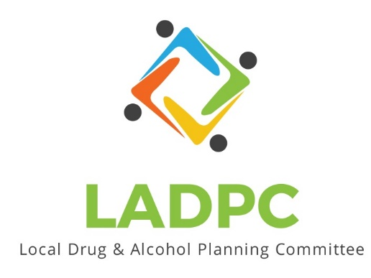

**____________________________**

3/24/2022 Coos County Local Alcohol and Drug Planning Meeting Notes

Present: Tara Johnson, Charlotte Carver, Tracy Herning, Ross Acker, Katrinka McReynolds, Alex Baum, Darrell Babb, Paul Gonzales, Deidrie Lindsey, Kera Hood, Samuel Denney, Scott Cooper

Absent: Antonio Angulo

|  |  |  |
| --- | --- | --- |
| **Topic/Speaker** | **Discussion** | **Action Steps** |
| **Introductions, guests listed** | Joseph Belter, Housing Dir. At SOCC  Dane Zahner, HIV Alliance  Caroline Dillon, Oregon  Judicial Dept. Family Treatment Coordinator  Lee Saltzgaber Chief Medical Officer BAH |  |
| Established a quorum | Yes |  |
| Approval of minutes | Alex Baum motion for approval of minutes of January 27, 2022 minutes.  Tara Johnson second to approve minutes of January 27,2022. | Minutes Approved no objections or discussion. |
| Presentation by Dane Zahner, HIV Alliance  *Harm Reduction* |  | Presentation on LADPC Basecamp- Docs & Files-Presentations-HIV Alliance March 24,2022. |
| **Topic/Speaker** | **Discussion** | **Action Steps** |
| Presentation by Katrinka McReynolds, Coos Health and Wellness.  *What is Prevention?* |  | Presentation on LADPC Basecamp- Docs & Files-Presentations-What is Prevention. March 24, 2022 Katrinka McReynolds |
| Ross Acker | Announced that LADPC has some seats available and to let him know if anyone is interested in joining |  |
| Charlotte Carver | Reviewed information shared at the last Statewide Alcohol & Drug Policy Commission meeting (ADPC).  According to OHA’s report on Opioid Overdoses in Oregon, from 2016 to 2020 prescription overdose deaths have been decreasing, however overdose deaths from heroin, synthetic opioids including fentanyl, and stimulants such as methamphetamine are increasing.  Most overdoses are happening at home, not at hospitals.  Majority of people who die from overdoses are not receiving mental health or substance use treatment services.  Full report can be found on Basecamp in Statewide Plans/Documents: [Linked here](https://3.basecamp.com/4276268/buckets/14875395/uploads/4709498603)  Reviewed Oregon Statewide ADPC Strategic Plan Goals (2020-2025), these are now on the top of the Coos LADPC Agendas:   * Reduce prevalence of substance use disorders (SUDs) and increase recovery * Reduce deaths from Alcohol Tobacco and Other Drug (ATOD) use and misuse * Reduce ATOD-related health disparities * Reduce economic burden of substance-use-related health and social problems | LADPC Basecamp- Docs & Files-Statewide Plans/documents-ADPC Statewide Strategic Plan Final. pdf |
| **Topic/Speaker** | **Discussion** | **Action Steps** |
| Charlotte Carver | Oregon Opioid Settlement money. Being negotiated. New money coming to Coos County. $34 million coming to Oregon. Could be $56 million more from bankruptcy plan.  Money will go to: Fund Prevention, Treatments and Recovery Services.  Message Board in Basecamp-Oregon’s Opioid Settlement Info-posted by Charlotte Carver March 24, 2022 |  |
| Ross Acker | Workforce Investment is saying that county does not have enough providers for:  Alcohol  Drug  Mental Health  Waiting to hear back on grant awards from BHRN (Behavioral Health Resource Network) who has a substantial amount of funding. Several local entities applied.  Need help from a consultant about a Sobering Center. | Before summer starts have more discussion on Sobering Center. |