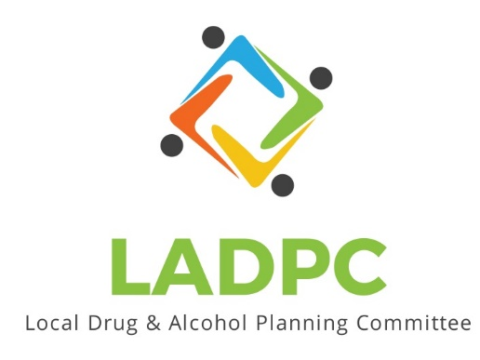

**____________________________**

4/28/2022 Coos County Local Alcohol and Drug Planning Meeting Notes

Present: Tara Johnson, Antonio Angulo, Charlotte Carver, Tracy Herning, Ross Acker, Katrinka McReynolds, Alex Baum, Darrell Babb, Paul Gonzales, Deidrie Lindsey, Kera Hood, Samuel Denney, Scott Cooper, Kate Frame, Steve Sanden, Denise Acker, Jerry O’Sullivan, Stephanie Pustejovsky, Amanda McCluskey, Caroline Dhillon, Kyle Stevens, Kent Sharman, Erin Stack, Dane Zahner, Trina Wheeldon

Absent: Katrinka McReynolds,

|  |  |  |
| --- | --- | --- |
| **Topic/Speaker** | **Discussion** | **Action Steps** |
| **Introductions, guests listed** | Attendees highlighted in yellow above | **None** |
| Established a quorum | Yes |  |
| Approval of minutes | Motion made and seconded | Minutes Approved no objections or discussion. |
| Presentation by Trina Wheeldon for Adapt  Sobering Center | Grants Pass has a center that allows voluntary admission  Transportation out of the center, not being released into the surrounding area.  Diversion numbers are goof for keeping folks out of the ER and jail.  Homeless vs housed is about a 50/50 split on who used the center.  Positive feedback from local law enforcement  Jerry O’Sullivan has lots of info about outreach to local leaders. Helped with buy in from their community.  Staff feels safe the LEO takes the person to the holding area. Staff is not put in harm’s way. | Presentation on LADPC Basecamp- Docs & Files-Presentations-Adapt Sobering Center Presentation 4/19/22 |
|  |  |  |
| Ross Acker | Announced BERN awards being posted Online |  |