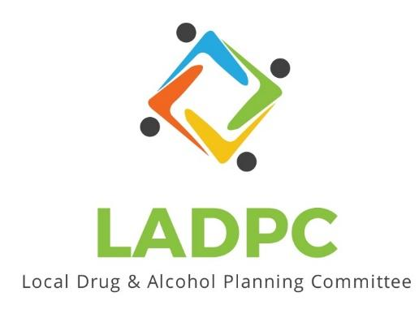

**____________________________**

4/27/23 Coos County Local Alcohol and Drug Planning Meeting Notes

Present: Tara Johnson, Charlotte Carver, Ross Acker, Katrinka McReynolds, Alex Baum,Officer Coleman, Paul Gonzales, Kera Hood, Samuel Denney, Scott Cooper, Caroline Dhillon, Dane Zahner, Leanne Hake

Highlighted names present.

| **Topic/Speaker** | **Discussion** | **Action Steps** |
| --- | --- | --- |
| **Introductions, guests listed** | Kate Stewart  Introduction to Officer Theran Coleman, Community Resources Office. Welcome to the board. | **None** |
| Established a quorum | Yes |  |
| Approval of minutes | Don’t have minutes from March 23, 2023, will approve in May 2023 |  |
| Discussion | **Ross** encourages everyone to watch the presentation.  **Caroline Dhillion** wants to add to the agenda: Addressing SUD in rural communities: Overdose fatality review committee The idea is to look at someone who passed from OD and look at what agencies they had contacted, criminal activity, police reports, MH treatment, medical treatment, PH treatment, schools. Reviewing info allowed them to make recommendations to the community about things that people could be doing to help.  PSA’s to remind people for example: that if they have been clean and relapse their tolerance is different or  Kids on IEP’s can stay in school until 21 and get services. . Findings that 8 service providers in their committee and 7.8 service providers had had contact with the deceased.  Would that work in Coos County? PH and LEO heavy in that group in the community that presented.  **Dane:** does the review look at RX or illicit drugs. PSA about naloxone would be good.  **Charlotte:** One thing that committee was looking at is if the person could have been saved if they had naloxone.  Sending a link to the group. Data dashboard is available for LEO and first responders to enter data.  **Tara:** Is interested, her community has a high risk population.  **Charlotte:** Great idea, start small, maybe one meeting a year? Maybe find what those deaths have in common.  **Ross:** Where would we want to focus efforts and what info can be shared? What are the areas that we want to focus on as a committee? Facebook presence for PSA’s,  **Charlotte:** We may need to have someone spearhead this, PH, Law Enforcement? Radio stations in HS? Once a quarter send out and see who picks it up. Family and friends need this info too, in case family or friends are using substances.  **Dane:** Leave behind kits, “if you are using go here for treatment”  **Tara:** Had a hard talk about folks resisting naloxone training due to stigmas. PSA’s a good thing.  ________  **Charlotte:** Can commissioners attend a May meeting?  **Ross:** Commissioners have an open invite to attend the meetings but no response.  **Charlotte:** Presentation goes over data and results from strategic planning from last year, measure 110 funding.  Turn into a report vs. presentation? Value in presentation but need to get the info out.  **Ross:** Ideas on how to get info out? PSA, Postcards, Group presentations.  **Dane:** Community Education like was done in Reedsport, do that in other communities.  **Caroline**: Wednesday Business Connection needs speakers.  **Ross:** WBC good idea. Walked through the Sobering Center in Roseburg and we need one where and need to raise funds. Good thing to talk to WBC about.  Police still want training on naloxone.  **Kera**: Coos & Curry BH meeting, next meeting they are having a presentation on naloxone including how to use.  **Charlotte:** Next month's plan? Was thinking they would be able to meet with the commissioner but that does not seem possible. What is the May plan? Slides have been updated. Statewide Alcohol & Drug commissions have monthly meetings that are recorded that you can watch. They have a lot of different committees. Link to meetings: <https://www.oregon.gov/adpc/Pages/Meetings.aspx>  67% of men 84% of women released from DOC indicated they have a SUD treatment need. High risk of OD once released.  **Caroline:** It is hard to get SUD treatment in prison.  __________  **Charlotte:** Showed Presentation on screen  **Dane:** Highlight some of the successes in presentation. Each organization gives a slide to show the highlights of what good they are doing and expanding services?  __________  **Dane:** Xylazine has hit Oregon, Dane sending info.  4:00pm Meeting adjourned. | Upload the new presentation to Basecamp.  Upload chat to Basecamp |
|  |  |  |
|  |  |  |