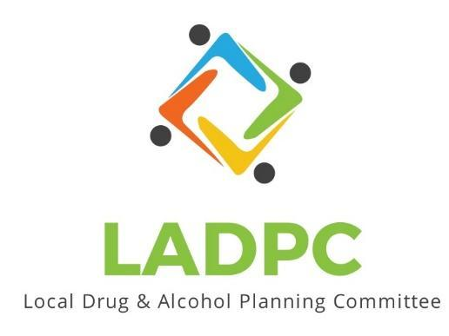

**____________________________**

3/23/23 Coos County Local Alcohol and Drug Planning Meeting Notes

Present: Tara Johnson, Charlotte Carver, Ross Acker, Katrinka McReynolds, Alex Baum, Paul Gonzales, Kera Hood, Samuel Denney, Scott Cooper, Caroline Dhillon, Dane Zahner, Leanne Hake

Highlighted names present.

| **Topic/Speaker** | **Discussion** | **Action Steps** |
| --- | --- | --- |
| **Introductions, guests listed** |  | **None** |
| Established a quorum | Yes |  |
| Approval of minutes | Motion to approve: Alex Baum, Paul Seconded the motion | Motion passes |
| Discussion | **Any Additions to the Agenda:**  Legislative Updates by Charlotte.  **Charlotte:** Membership Updates: Charlotte shared screen of Membership. Tara and Charlotte renewed by BOC.  Have a couple of vacancies, Coos County Corrections and Coos Juvenile. Coos Bay Police submitted Officer Coleman to appointment by BOC and reappointment of Paul Gonzales waiting for BOC vote.  Christine from ADAPT is interested in joining LADPC.  Bylaws state may have a student on the board. SOCC maybe? Think about how to make decisions on the last couple of spots on the board?  Need to make sure the meetings are posted as public.  Adding to bylaws to allow for a stand-in from an organization to allow stand-in when the original member is out?  Have a new member packet.  Tribal representation, they have had a lot of change in staff, revisit.  Need geographic representation.  Officer elections have expired, officer elections in May or June 2023 to get all new members appointed.  **Tara:** Should we ask Shane Dunning from NBPD Community Resource Officer to join?  Would it be beneficial to look at who we are missing in the county? Like MP, Coquille, Bandon. Dane seconded the idea.  **Samuel:** Post internally at ADAPT about meetings and membership?  **Leanne Hake**: Coast Community Health did not know about LADPC.  **Caroline**: Should we have someone from School Districts?  Multiple people from an agency is ok but maybe only one vote?  **Paul**: June would be good to allow new members to attend at least one meeting before elections.  ____________  Charlotte: Program Updates:  Making changes to the LADPC PowerPoint, have new and updated data. Highlight some program changes.  Invite BOC to the April 27th LADPC meeting.  BAFS room available for the April 27th meeting.  Postcards need to be printed for the April 27th meeting?  Logo needs fixed.  Caroline: Q: Where will the postcard be placed?  A: Hand out at presentations, leave behind kits, CHW, police officers.  Motion to approve the Postcard to be printed. Dane motioned, Tara seconded. Motion Approved  BURN updates:  **Paul BAFS**: working on updating peer support specialists training. and MH peer support training. Working to create a workforce for peer support. Training is scheduled for the workforce training. On the job work experience, any ideas of places for on the job are welcome. Let Paul know.  **Sam ADAPT**: nothing on OTP side. Did not get a peer mentor thought it got cut. no changes on his end.  **Dane HIV Alliance**: naloxone training in Libraries going well. Another training in April. Harm reduction peer to be hired from 110 funding.  **Katrinka:** She does not know about BURN funds and will check with David in BH. Applied for grant for Leave Behind kits, but have not heard back  **Caroline**: Family Treatment Court grant coming due, hopeful to have more people interested. Expanding Parenting Services, specific to folks in recovery or with SUD.  **Leanne Pacific Pain**, asked their State auditor if they needed a special license to work with Youth. Hoping by the end of April beginning of May to have info about working with 14-18 year old youth treatment.  **Charlotte:** Legislative Updates:  Statewide Alcohol & Drug policy commission started meeting again. Meetings are recorded and they share a lot of great info. Will post in Basecamp where to watch the video.  HB 2395 is ADPC is in favor of the bill which increases access to naloxone, decriminalized harm reduction supplies, reduces barriers to minors seeking SUD treatment and establishes protocols for OD reporting.  Potential changes to 110 funding HB 2089 would change marijuana distribution formula which affects BURN funding.  Meeting adjourned. | Get notices out about meetings encouraging people to join meetings. |
|  |  |  |
|  |  |  |