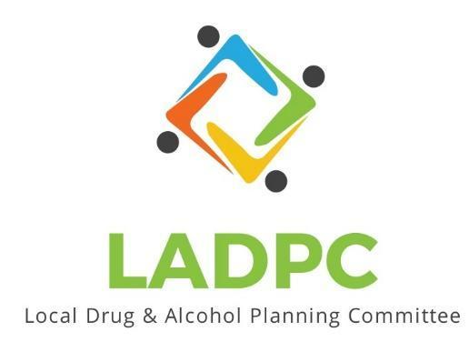

**____________________________**

5/25/2023 Coos County Local Alcohol and Drug Planning Meeting Notes

Members: Charlotte Carver, Ross Acker, Katrinka McReynolds, Theran Coleman, Paul Gonzales, Kera Hood, Samuel Denney, Scott Cooper, Caroline Dhillon, Dane Zahner, Tara Johnson ,Alex Baum, Leanne Hake

Highlighted Members Present for May 25, 2023 meeting.

|  |  |  |
| --- | --- | --- |
| **Topic/Speaker** | **Discussion** | **Action Steps** |
| **Introductions, guests listed** | Kara Long, Commissioner Rod Taylor  Members introducing themselves to Commissioner Taylor  Commissioner Taylor is interested in the ongoing work and looking to support the efforts of LADPC. | **None** |
| Established a quorum | Yes |  |
| Approval of minutes | Motion by to approve minutes from March and April 2023: Dane Zahner, 2nd by Scott Cooper | Minutes Approved no objections or discussion. |
| Discussion | Charlotte is turning the presentation into a report form to help get the word out.  Opioid settlement money, maybe City and County can align ways to spend the settlement money.  Charlotte showing the LADPC Presentation  Ross talked about visiting the Sobering Center in Roseburg.  Access and knowledge of services is key to addressing the need in the community.  Officers election discussions, open positions:  Chair  1st Vice Chair  2nd Vice Chair  Ross is flexible, will step down or continue to be Chair.  Charlotte explaining roles, Chair, both Vice Chairs and Member at large meet as Executive Committee one other time a month to discuss agendas.  Tara: Thinks we have made such good leadership and understands if folks need a break but continuing the leadership she feels the momentum will continue.  Scott: Agrees momentum will continue and would love to have members stay  Paul: Stretched very thin so can't commit to an officer position but wants to stay on committee.  Charlotte: We should have elected new chairs last year. Elect officers in June so we could be back on schedule.  Commissioner Taylor: possible funding source Ford Family Foundation? Many hands make light work, if a lot of places pitch in for Sobering Center might make it easier.  Tara: Might not meet their focus  Kera: Kate Frame is spearheading the search for funding hired for Sobering Center fundraising. Judith Ann Mogan foundation supported this hire. Many letters of support from all over Coos County.  ADAPT runs the Roseburg program and can run the Coos County one.  Ross: LEO supports the current jail as a site for the Sobering Center.  No July meeting but holding open availability if commissioners want a meeting at Owen Building. | Ross to send an email about officer elections for the June meeting. Will need a quorum for the June meeting |
| Discussion | Commissioner Taylor suggested scheduling a time to do a public presentation at the Owen building. Public and commissioners invited. |  |
|  | Meeting adjourned at 3:58pm |  |