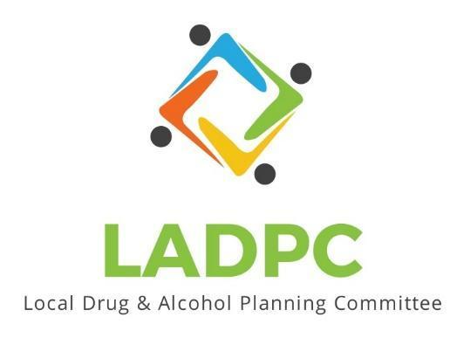

**____________________________**

2/23/2023 Coos County Local Alcohol and Drug Planning Meeting Notes

Members: Charlotte Carver, Tracy Herning, Ross Acker, Katrinka McReynolds, Paul Gonzales, Kera Hood, Samuel Denney, Scott Cooper,Caroline Dhillon, Dane Zahner, Tara Johnson, Alex Baum

Highlighted Members Present for Feb. 23, 2023 meeting.

| **Topic/Speaker** | **Discussion** | **Action Steps** |
| --- | --- | --- |
| **Introductions, guests listed** | Kate Stewar (Independent Consultant), Chrystine Deuel (ADAPT) Theresa Keys (BAFS) | **None** |
| Established a quorum | Yes |  |
| Approval of minutes |  |  |
| Dane Zahner | Naloxone resources, Police chief in Brookings got access to naloxone, eligibility requirements for Save Lives Oregon, | Coos Bay, North Bend PD needing access to naloxone. |
| Discussion | Ross: Presentation from last October is a great summary to the working being done  Motion to approve minutes from October 2022 meeting made by: Kera Hood, seconded by Katrinka McReynolds, motion passed.  Ross: Open committee spots to be filled. Tara Johnson, Charlotte Carver and Tracy Herning’s terms expired November 2022. Tracy said she is not interested in being reappointed.  Scott Cooper made a motion to reappoint Tara Johnson and Charlotte Carver, Dane Zahner seconds motion, motion passed.  Officer Darrell Babb retired 12/31/22 Ross talked to CBPD Officer Therin Coleman and sent him an application.  Antonio Angulo moved to another position and Bryan Baird said he may have 2 new juvenile probation officers that may be interested.  Leanne Hake has her application in and it has been forwarded to the commissioners.  Paul Gonzales term is up as well, Scott Cooper made a motion to reappoint, Kera Hood seconded, motion passed.  Charlotte brought us checking the bylaws to see if stand-in members from the same organization are allowed.  Charlotte: New membership packets can be shared with new people and people that are interested.  Email Ross any feedback about last October's presentation.  Charlotte mentions that she has other groups that would like a modified version of the presentation for different committees.  Caroline: important to show drug exposed kids/infants. But she is not sure how to capture the data.  2023 DHS is starting to capture that data.  Important do know how substance abuse is impacting children and families.  Charlotte shared her screen on compiled info on access to SUD treatment and recovery. OHSU contracted to have the report put together. Our region has the highest inadequacy capacity of all the regions in the state.  Travel and transportation is a barrier to clients  Dane: Talking about Save Lives Oregon, should be using the opioid settlement to purchase naloxone for PD’s  Postcard , trifold needed  Kera 10.5 million coming to Oregon for Public Housing, NBHA and CCHA to get $570,000 | Notify Bobbi Brooke on the 3 reappointments.  Quarterly updates to the October 2022 presentation.  Get info from Charlotte on the report she shared on her screen about access to SUD treatment and recovery services. |
|  | Meeting schedule to be emailed. Meeting adjourned 4:00pm |  |