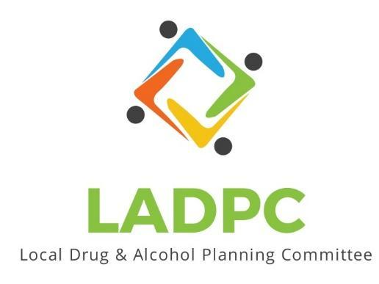

**____________________________**

6/23/2022 Coos County Local Alcohol and Drug Planning Meeting Notes

Members: Charlotte Carver, Tracy Herning, Ross Acker, Katrinka McReynolds, Darrell Babb, Paul Gonzales, Kera Hood, Samuel Denney, Scott Cooper,Caroline Dhillon, Dane Zahner, Tara Johnson, Antonio Angulo,Alex Baum

Highlighted Members Present for June 23, 2022 meeting.

| **Topic/Speaker** | **Discussion** | **Action Steps** |
| --- | --- | --- |
| **Introductions, guests listed** | Kara Long, Heather Surgeon, Kate Frame,Sara Stephens, Stephanie Pustejovsky, Erin Stack, Denise Acker, Brett Hamilton,Karen Drill  Dial in 541-982-9899, 541-613-1393 | **None** |
| Established a quorum | Yes |  |
| Approval of minutes | Motion by Paul Gonzales 2nd Katrinka | Minutes Approved no objections or discussion. |
| Comagine Health/Synergy Health Consulting/  Lines for Life | SPI Presentation by Denise Acker, Karen Drill and Stephanie Pustejovsky & Erin Stack | Fentanyl OD’s on the rise.  Need advertising to direct people on how to get naloxone.  Need detox/sobering center in community.  Need for more MH care in community.  Presentation will be added to Basecamp’s Presentation folder |
| Discussion | Dane Zahner talked about **Save Lives Oregon** and how organizations can get naloxone.  Ross Acker mentioned the National **Health Service Corps**. Similar to the Peace Corps, it attracts doctors & MH clinician to move to rural areas. In exchange for services it repays student loans.  Ross also mentioned Oregon has been talking about establishing a statewide BH loan repayment program to attract more BH clinicians.  Denise Acker is setting up a Google Jam board for posting ideas/notes/actions. | Do members have the Google Jam board link? |
|  | Meeting schedule to be emailed. Meeting adjourned 3:51pm |  |
|  |  |  |
|  |  |  |
|  |  |  |