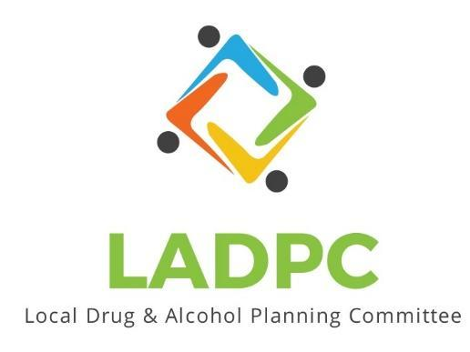

**____________________________**

10/26/23 Coos County Local Alcohol and Drug Planning Meeting Notes

Present: Tara Johnson, Charlotte Carver, Ross Acker, Katrinka McReynolds, Alex Baum, Paul Gonzales, Kera Hood, Samuel Denney, Scott Cooper, Caroline Dhillon, Dane Zahner, Leanne Hake, Officer Theran

Highlighted names present.

|  |  |  |
| --- | --- | --- |
| **Topic/Speaker** | **Discussion** | **Action Steps** |
| **Introductions, guests listed** | Kate Stuart/Frame | **None** |
| Established a quorum | Yes |  |
| Approval of minutes | Dane motion to accept the minutes from last meeting Caroline 2nd the motion | Motion passes |
| Discussion | Kate Frame Sobering Center update:  Jail has offered up space for free for the Sobering Center. ADAPT willing to operate the space in the jail. Find funding from community and from grants to sustain the program as the people brought to the center cannot be billed. April 2024 opening is possible.  How can LADPC continue to collaborate to ensure it is successful. Steering committee of Sobering Center become a subcommittee of the LADPC. Serve to make sure services are coordinated. LADPC help ADAPT find grants and funding. Kate drafting a document between LADPC and ADAPT about this relationship.  Kate would like to create a letter of thanks for grant reporting to the Judith Mogan Foundation.  Ross got a call from Mike Rowley last week saying that BOC is wanting to make this happen, with lead from John Sweet.  Blended funding streams, opioid settlement money, grant money and Advanced Health.  Local leadership is on board with what the sobering center can do for the community.  Ross: Baseline data is now available through Tableau in form of dashboards. Ross gave tour of the dashboard. Ross is wanting to get this information so the public can access.  How do we want to display this data to the public for the most impact? Can invite the data analysist to a meeting.  Sam Denney did an opioid talk at the North Bend Library  Educating the providers on what is available in the community. Contact medical centers to do education on what is available and how to get in contact with SUD providers locally.  Caroline, Curry Co wanting postcards. Kara Long can design once information is delivered to her.  Work with SOCC to have gathering in one of their spaces.  Upcoming meetings: Combine Nov & Dec. meetings? November 30th LADPC meeting?? Will try and set up a date after the community meeting date has been established.  Last week of November or early December community meeting about Sobering Center. Date and time TBA. LADPC members to attend.  Possibly extend meetings in the future to 1 ½ hrs.  Meeting adjourned 4:01pm |  |