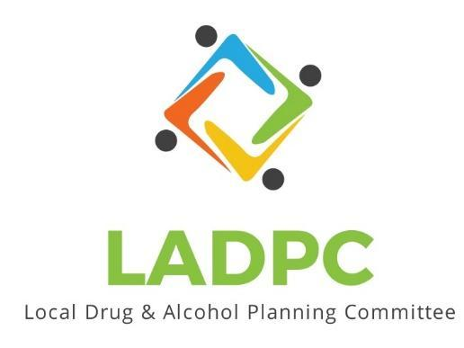

**____________________________**

9/28/23 Coos County Local Alcohol and Drug Planning Meeting Notes

Present: Tara Johnson, Charlotte Carver, Ross Acker, Katrinka McReynolds, Alex Baum, Paul Gonzales, Kera Hood, Samuel Denney, Scott Cooper, Caroline Dhillon, Dane Zahner, Leanne Hake, Officer Theran

Highlighted names present.

|  |  |  |
| --- | --- | --- |
| **Topic/Speaker** | **Discussion** | **Action Steps** |
| **Introductions, guests listed** | Jennifer I. Invited by Katrinka to network, Chrystine Deuel, program manager ADAPT. | **None** |
| Established a quorum | Yes |  |
| Approval of minutes | Motion to approve Dane motion to accept, Caroline 2nd  Motion passes | Motion passes |
| Discussion | Passes out changes to By-Laws changes in yellow.  2 changes,   1. Removing requiring student representative have not been able to recruit a student.   Discussion: still allow them on if we can find one. Will be challenging for a student to attend regular meeting, so maybe someone who works with students in recovery would be a good fit.   1. Adding a stand in person from their organization   Motion to pass the 2nd revision to the bylaws, passes  **Membership Recruitment**  SOCC should have some sort of services, recovery group?  Chrystine did presentation at SOCC a while ago and students were engaged.  Invite folks to the next meeting to see if they are a good fit.  Regional distribution, look outside of CB/NB.  Don’t have any tribal representation currently.  A SOCC student may be able to get credit for attending.  Katrinka & Dane have been at MHS with Leadership students. Would like someone with Juvenile Justice.  Youth ERA, ARK at MHS possible member, Coast Community Health, Ailsa from Rachel Stappler’s office?  **Commissioners Meeting:**  Take aways from the meeting:  Dane had good interaction after with commissioners and felt it was positive.  Ross: their priorities are different from LADPC.  Charlotte: 2hr meeting with R. Taylor and J. Sweet were in attendance.  Some resistant to Sobering Center, misconception about funding around treatment. Good opportunity to show work that is being done. Good that organizations that receive BURN funding were there to share how they are using the funds.  Dane: need to make sure they understand the process of recovery, it is not just treatment once and done.  Tell the story of addiction in Coos County.  Caroline: know our audience, tailor the message to the audience.  Tara: Myth that we have enough treatment. Are BAFS or ADAPT tracking how many people are waiting for treatment? Not just Roseburg but here as well. How many people are lost back to addiction because of the wait?  **Additional Discussion:**  Ross: OHA had a dashboard, just waiting to see what he can share publicly.  Kera: Hear stories about how hard it is to get through to places. Should the group do an assessment on how long it takes to get through the process. A Gamba Walk as a patient. Great way to identify gaps and barriers.  CHIP grant? Got delayed should hear soon.  Grant written to print materials and to host events/community education.  Sobering Center planning discussion on next agenda.  Caroline had good conversation with Kids Hope Center, about doing referrals for kids they come in contact with that kids that they come in contact with that may have SUD.  Ross: Unite Us I set up, is anyone using it?  Add Unite Us to next agenda.  Meeting adjourned 4:10 | Kera, reach out to SOCC contact?  Dane, reach out to MHS about presentation.  Honora Buell, Ed.D.  Director of Academic Partnerships 541-888-7893  Z-Club  [Paulabechtold@gmail.com](mailto:Paulabechtold@gmail.com)  Tara will ask Ailsa |