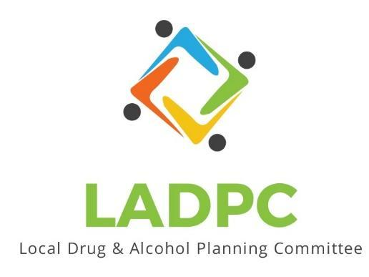

**____________________________**

6/22/23 Coos County Local Alcohol and Drug Planning Meeting Notes

Present: Tara Johnson, Charlotte Carver, Ross Acker, Katrinka McReynolds, Alex Baum, Paul Gonzales, Kera Hood, Samuel Denney, Scott Cooper, Caroline Dhillon, Dane Zahner, Leanne Hake, Officer Theran

Highlighted names present.

|  |  |  |
| --- | --- | --- |
| **Topic/Speaker** | **Discussion** | **Action Steps** |
| **Introductions, guests listed** | Kate Stuart, Jeanifer, | **None** |
| Established a quorum | Yes |  |
| Approval of minutes | Motion to approve: Tara , could not tell who seconded but was seconded and | Motion passes |
| Discussion | Officer Elections:  Consensus is to maintain leadership.  Vice Chair to take Alex Baum’s place. Katrinka nominated Charlotte Carver for Vice Chair. Tara seconds nomination, Alex Baum agrees that is a great nomination to replace her.  Motion passes, Charlotte Carver Vice Chair  Chair Position: Kera nominated Ross and Tara seconded Ross for Chair. Motion passes, Ross Acker, Chair  2 more positions: 2nd Vice Chair and Member at Large  Charlotte recommends Katrinka for 2nd Vice Chair, Tara seconds nomination. Katrinka accepts the nomination.  Motion passes, Katrinka McReynolds 2nd Vice Chair.  Member at Large: Caroline Dhillon is interested. Tara nominated Caroline someone seconded but could not see who it was.  Motion passes, Caroline Dhillon is Member at Large.  Ross sent Membership Excel sheet around to be updated, it is on Basecamp as well.  Presentation scheduled for next week in the Owen Building to the BOC. Ross, Charlotte, Caroline, Tara, Paul, Dane, Samuel all planning on being there in person. Public meeting anyone can come 1pm. Ross will talk about Sobering Center, Ross would like to show video showing what Sobering Centers are all about.  Sam can see if the Douglas Co. Sobering Center director can come or Zoom in.  Charlotte will send out most updated version, and please send comments/corrections to her.  Dane will speak about naloxone and settlement money.  Charlotte discovered interesting part of the funding. Could be money to support a Sobering Center combined with other funding Kate Frame has found.  Opioid Settlement funds are hard to track  First money went out is 2022, Coos County received $500,000. LADPC can highlight what can be done with the funds. Like opening Sobering Center. City of Coos Bay also getting funds, used to purchase naloxone and drug take back and city is open to other recommendations.  Would like to get some sort of commitment from County and City to show support for other funders.  Monies will be coming from settlement for the next 18 years.  Exhibit E showing how funds can be used. Hundreds of thousands of dollars unallocated and that is why LADPC is here to help advise how to use the settlement money.  Tara: We really need to figure out a way to get more and faster treatment options. Need inpatient in Coos County.  Charlotte posted in chat: *Here are the top needs identified in the Needs Assessment: The most frequently mentioned needs were: Sobering center, Detoxification center, Expanded treatment options (inpatient, outpatient, residential, and telehealth) Quicker access to care for people with SUD More, naloxone, Expanded Peer Support Services for specific groups (Veterans, Youth, Parents, Formerly incarcerated)*  Crisis Stabilization Unit: Paul can explain in meeting about this.  16 Person housing unit opening behind Dominos Pizza on Ocean Blvd. And lots of Peer support has been hired due to the funding.  Paul will put bullet points together on how funds are used and services have been expanded.  Goals for the year:  Overdose tracking  Communication Plans  Distribute Report  SUD co-occurring with Mental Health. Big gap.  Access to treatment while incarcerated is not good, how do we address that? Big gap.  Get Postcards out to everyone that can use them.  Ideas where we can present to others in the community?  Chamber of Commerce (shorter modified presentation),  Patrol officers maybe thru rollcall, Officer Theran said officers liked the postcards  Homeless coalition, Theran will get contact to Ross.  Chiefs meetings the one in Bandon.  Service Clubs, Rotary, Soroptimists Club |  |
|  |  |  |
|  |  |  |