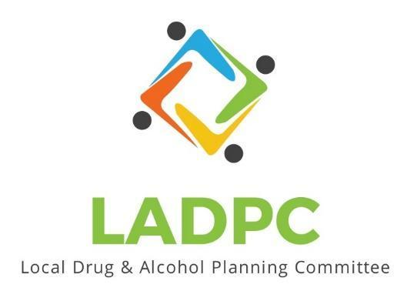

**____________________________**

March 28, 2024 Coos County Local Alcohol and Drug Planning Meeting Notes

|  |  |  |  |  |  |
| --- | --- | --- | --- | --- | --- |
| **LADPC Members:** | | | | | |
| Ross Acker | X | Tara Johnson, | X | Scott Cooper |  |
| Charlotte Carver | X | Katrinka McReynolds |  | Officer Theran |  |
| Caroline Dhillon | X | Alex Baum | X | Paul Gonzales |  |
| Samuel Denney |  | Lexi Sylvester |  | Chris Webley | X |
| Leanne Hake |  | Bryan Baird |  |  |  |

|  |  |  |  |  |  |
| --- | --- | --- | --- | --- | --- |
| **Guests:** | | | | | |
| Chrystine Deuel ADAPT | X | Jen Jordan with ADAPT | X |  |  |
| Kara Long | X | Cory Potts SCREL HUB | X |  |  |

Present (X)

|  |  |  |
| --- | --- | --- |
| **Topic/Speaker** | **Discussion** | **Action Steps** |
| **Introductions, guests listed** |  | **None** |
| Established a quorum | Yes |  |
| Approval of minutes | Motion to approve: Alex motion to approve, Caroline 2nd. Motion passed | Motion passes |
|  | Chrystine sent application to become a member. Ross has not heard back from the county. Chrystine will replace Sam Denney from ADAPT.  Updates:  Ross:  Sobering Center:  ADADT proposed budget sent out via email.  $400,000 was put into a recent house bill 5204 states that funds are for development. HB5204 is for all over the state for support of a sobering/crisis stabilization centers all over the state.  ADADP Chief sent MOU to County Council for review.  SFO does have to move evidence from that section to a secure location at a cost of $35,000.  Charlotte:  HB 4002 will re-criminalize drugs.  HB 5204 which has new funding to support the sobering center.  Kara shared about It’s Time Event  Caroline:  Funding from treatment courts. Treatment Court task force is being put together on a state level.  HB5204 has funds for counties that want to start deflection programs, Coos was not named but Curry was names. When people are getting misdemeanors, we have to do conditional discharge. Most cases will be expunged if you do treatment. There are grants to help do training with deflection program.  Ross: LADPC could advocate for the deflection program.  Chris: re-criminalization and conditional discharge program. User amounts of drugs, PO would answer questions and lay out the program. Goal is to work with as many partners to make it a success.  Outreach event at SOCC in the Fall, maybe have stories at the event.  ODHS:  Alex:  Plans of Care to help reduce the need to child welfare involvement. For Substance affected infant under 1. (slides showing info about Plans of Care)  Addiction Recovery Teams (ART) work with families at any level in the system.  ART Team: work with Child welfare and addiction treatment program.  Slide shown (get slide for Basecamp)  Right now the ADAPT position is Coos County only.  Family Treatment Court: Caroline  2022 was started now on hold. ADAPT was a partner, child welfare and public defenders. Early intervention was important. Was a phased program that you worked through during the recovery process. ART team was involved. Accountability every week was key. Possibly revamp the program to make it more appealing to the judge. UA’s were key to holding people accountable. Kids get back to parents faster through Family Treatment Court.  Coos County has Mental Health Court. Co-occurring piece connection with treatment providers needs improved.  Mom’s ( Families) in Recovery Program. ADAPT and Pathways to Positive Parenting working together. PPP purchasing curriculum.  Created to support families affected by SUD. Mid May possible start up.  Charlotte:  New Programs expanding in our area:  Healthy Families Oregon is now enrolling for Home Visiting Coos and Curry  Relief Nursery is now Coastal Families Relief Nursery.  Family Connects would be universal home visiting.  Nurture Oregon or Project Nurture, care for families that are pre-natal or post-partum for SUD.  Meeting adjourned 4:30pm |  |