Thunder in the East consolidated errata and ETO rules evolution retrofits

A game the size of Thunder in the East is going to have some errata. Longtime wargamers (“grognards”) know that some things inevitably slip through the cracks or that clarification here and there will help. That is the first part of this document, mending small things in your out-of-the-box copy of Thunder in the East.

TITE Errata: 18 December 2019
If you have questions or think something might be missing or requires adding, please contact us at: AlanEmrich@gmail.com.

Off-Map Rail Connections
Confirmation: The Soviets can use rails leading off map edges as though connected elsewhere along that same edge for purposes of Rail movement and tracing a RLoC. Note that the Vyborg rail line leads to Finland and so this off-map capability is unusable there.
- Note that the white rail lines (e.g., north of Kirov) are treated as Roads not Rail Lines in TITE. You may upgrade them to Rail Lines in the full ETO game.
- All rails leaving the map between A327 (near Vologda) and C753 (the north and east map edges north of the Caspian Sea), are connected by a Soviet RLoC, as are those between C768 and B470 (south and east map edges). Thus, the Soviets cannot trace an RLoC to Leningrad via Volkhov and Lodeinoye Pole because the Finns have retaken that part of their country.

The Crimea “Rail Bridge”
Clarification: You can cross the hexside between 9860 and 9861 using Rail (15.4) or “road” movement (14.2). You cannot overrun (17.1) or attack across this hexside and ZOCs do not extend across it.

Finland is OUT
Finland is out of play and prohibits entry into its hexes and those in the Arctic Theater. Note that Finland includes most of Karelia to hexes 8826, 8827, and 8926. It will be a squeeze for the Soviets north of Leningrad!

Counters
Both Factions’ Offensive Point (OP) markers should have a +1/2 on their reverse sides (not a copy of the x1 version on their fronts).

The two Soviet Li-2 Transports should not have a white Bolt.

The Romanian HS-129 should not have a Bomb Strength on its Damaged side.

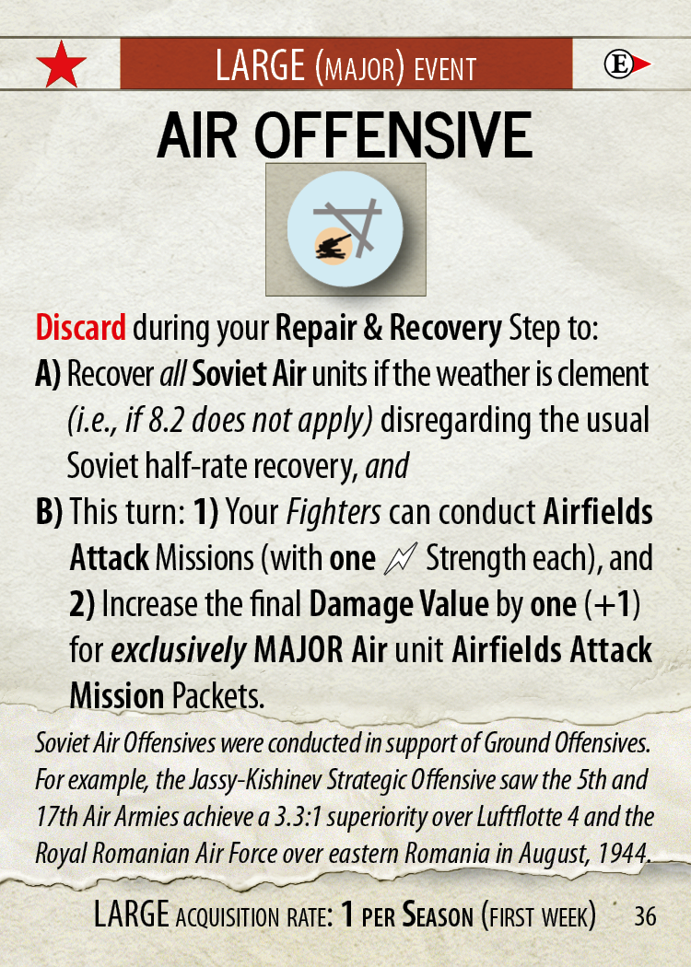
Soviet Cards

#05, Exile Forces: Change: This is a Small event card (not a Large one).

#10, You Have the Nerve…?: Change: This card should begin with: “If it is before 1943,…” That is, you cannot use it in 1943 or later.

#15, Great Patriotic War: Clarification: This card does not add PPs or EPs to the Soviet pool! It only allows the Soviets to exceed that turn’s 10% spending limit by up to 4 PPs and 1 EP.

#15, Commissars Motivate Troops: Clarification: This applies to the Final Odds (after Close Support) of 3:1 or lower. The Soviet player is effectively paying to change the die roll to the AP result. Since an AP result is impossible at 4:1 or better, the Soviet player cannot buy that result.

#36, Air Offensive: Change (we inadvertently give the Soviets an Axis- or Allied-strength Air Offensive card when they required the Soviet-strength version, which is still very good): The beginning of the card should now read: “Discard during your Repair & Recovery Step to: A) Recover all Soviet Air units if the weather is clement (i.e., if 8.2 does not apply), disregarding the usual Soviet half-rate recovery, and B)…” [use the same text for B].

Player Aids

Soviet Display: On the top-right it references the Liberation Ideology card, which is now the Soviet Exile Forces card (#5)

Scenario Book

See separate document.

Rules Book

Hex Control: It is important to know who controls each City hex and how that control changes.

The rules (with this errata) do not rely on a concept of control of non-City hexes, but instead generally look for either a friendly OLoC (to define Friendly Territory) or no friendly OLoC to any friendly City hex (to define Enemy Territory).

At Setup: You control all City hexes on and behind your setup positions at the start of the game.

Changing Control: During play, control of City hexes changes when:
- An opposing Ground unit physically occupies or conducts overland movement through that hex; OR
- As instructed when a nation collapses or a card so specifies.

The Faction that built it controls a Defense marker.

Place a Control marker as a mnemonic in any City or Improved Defense marker hexes that might be unclear.

When an Anchorage is captured, enemy Naval units there must immediately put to sea (see 106.3 for Fleet rules).

[3.4] Reserve Deployment: Simplification:
- Place Garrison Infantry and Hardened Garrison units, and Improved Defense and Fortified Defense markers, on your side of the Scenario Start Line, within the stacking limit (11.1),
A) In a specified setup location regardless of LoC; or
B) In a hex which can trace an OLoC to a friendly City hex that, itself, has a RLoC or NLoC.

[5.2] ZOCS and Combat: Add exception:
Each EZOC hex Retreated into causes that unit or stack to suffer one step loss (see 21.7) by their owner with these exceptions:
- Shared Hexes: ZOCs do not affect units Retreating from Shared hexes. A “shared hex” situation can occur during an Overrun or Amphibious Landing, for example.
[7.2] The Supply Routine: Clarification:
What we missed in the original rule was a sequence for checking supply. Here is the order in which you think about a unit’s supply routine:
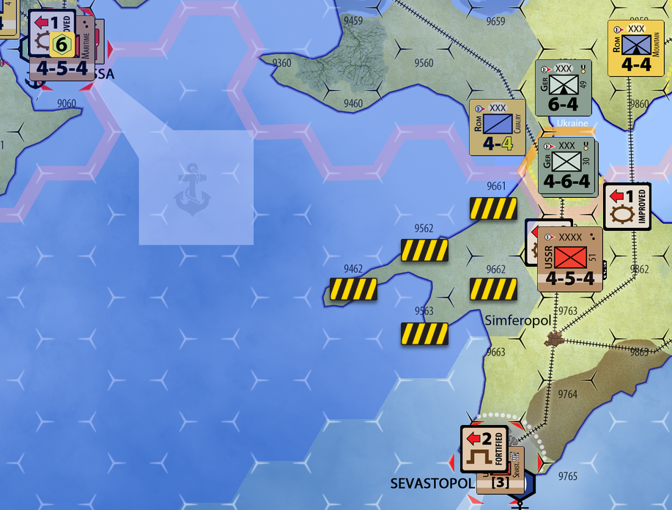
1. Does it have a LoC?
- If NO, it is Isolated.
- If YES, go to 2, below:

2. Is it within the radius of, and has an OLoC or RLoC to, a functioning supply source?
- If NO, it is Unsupplied.
- If YES, it is Supplied.

For example, the black-and-yellow highlighted hexes in this illustration are Unsupplied for the Soviets at the start of the Operation Typhoon scenario even though Odessa is a functioning Supply City. Its “supply umbrella” does not extend where an OLoC cannot be traced to it.

That's really all there is to it.

[7.5.3] Effects of Isolation: Last bullet:
You make only a single Attrition roll for all of the Isolated enemy Ground units in that hex (non-Isolated units are unaffected).

[9.0] & [9.7] Flown the Coop: Change: Permanently remove from play Withdrawn and Upgraded Air units.

[9.3.2] Motorized Units: Color: The reference to the Build Cost chart’s yellow highlight should be to its black bar.

[9.4] Building/Rebuilding Markers and Units from Your Force Pool: Smoothing the placement instructions for Garrisons and Improved Position markers:
- Place each Garrison Infantry unit in a Land hex, within the stacking limit (11.1), as follows:
- In a friendly City hex that, itself, has a RLoC or NLoC; or
- With a friendly Ground unit that, itself, has an OLoC; or
- In a Rail hex with no EZOC and that can trace an OLoC along the rail to a friendly City hex that, itself, has a RLoC or NLoC; or
- In a Coastal hex with no EZOC and that can trace an OLoC along the coast to a friendly Anchorage hex that, itself, has a RLoC or NLoC; or
- In a hex with no EZOC or enemy unit in it and that is adjacent to a friendly Garrison Infantry or Hardened Garrison unit that, itself, has an OLoC (allowing you to “build a line” from it).
- Place each Improved Defense marker in a Land hex within the stacking limit of one Defense marker per hex (11.1) as follows:
- In a friendly City hex that, itself, has a RLoC or NLoC; or
- With a friendly Ground unit that, itself, has an OLoC; or
- In a hex with no EZOC or enemy unit in it that can trace an OLoC through an adjacent (line of) friendly Defense marker(s) to a friendly Ground unit (that, itself, has an OLoC) or friendly City hex (that, itself, has a RLoC or NLoC).

[10.2] HQ “Movement:” Redraft of the entire 10.2 rules set
Your HQ markers do not move per se. At any time during your Special Movement Phase, you may pick up HQ markers in friendly City hexes and relocate them to supplied friendly City hexes for free. In extremis, your HQ markers can dissolve.
[10.2.1] Voluntary Relocation: If your HQ marker has an RLoC or NLoC, you can voluntarily relocate it to a supplied friendly City hex. After relocating, it arrives in Balanced mode with a -3 Countdown marker (see 8.0, #1) on it. It takes this long to reorganize it and reestablish its logistical functions.
If your HQ marker cannot establish an RLoC or NLoC during your Special Movement Phase, you cannot relocate it but can instead dissolve it (per 10.2.2).

[10.2.2] In Extremis Relocation: When your HQ marker “bugs out” of a bad situation, it dissolves and the opponent receives a reward. Your HQ marker dissolves if:
- You relocate it during your Special Movement Phase but it has no RLoC or NLoC permitting its orderly escape (per 10.2.1).
- During your opponent’s Supply Step, your HQ marker is not In Communication (7.0).
- An enemy Ground unit enters its hex and your HQ marker is alone (i.e., without a friendly Ground unit protecting it).
Dissolving: That HQ marker’s owner traces an Overland LoC (7.1) from its City hex to any other supplied, friendly City hex and places it there. Because it must reform in (rather than relocate to) that hex, it is in Balanced mode and also acquires a -4 Countdown marker (like a newly conquered Supply City or Major Port per 22.0).
Booty: When an enemy Strategic HQ marker dissolves or is eliminated, you immediately gain (but your opponent does not lose) 1 Fuel Point as “booty.” Operational and stressed Strategic HQ markers provide only 1/2 Fuel Point in “booty” when dissolved. If Partisan units caused its forced relocation you receive no Booty. They brought matches.
Elimination: If your HQ marker is unable to reform (because it cannot trace an Overland LoC to escape, see above), return that HQ marker to its Force Pool. You can rebuild it from there as usual.

[10.2.3] Untimely Relocation: Your HQ marker can relocate or dissolve even if it currently has a Countdown marker, but doing so resets its Countdown marker to -3 or -4, as appropriate.

[10.3.1] Attack Mode: Second bullet, second sub-bullet; change to:
Alternately, a German Strategic HQ marker in Attack mode can provide a single “Narrow Front” double shift (2>) Attack Bonus that turn (instead of multiple Broad Front shifts). That attack must include at least one German Ground unit. The Axis player must announce when exercising this option during their Battles Declaration Step (19.1).
The “HQ (two shift) Hammer” is an exclusively German thing.

[11.1] The Physical Stacking Limit: Change to ease the restriction on Garrison unit placement:
A stack may include more than one Garrison unit. There can, however, still be only one Hardened Garrison unit and one Defense marker in a hex.

[12.7] Involuntary Breakdowns; Last Stand Clarification:
Change “You may place it on the map (where it can still…” to “You may replace it on the map (where that Corps Remnant unit is still subject to…”

[14.2] “Road” Movement Bonus: Clarification (last sentence) added:
Ground units can use the rail line in a hex as a “road” through that terrain. A Ground unit moving along a Railroad (i.e., moving from one Railroad hex to another, adjacent, Railroad hex connected by a rail line through their shared hexside) pays only one Movement Point to enter that hex, regardless of the normal terrain costs to enter it. You cannot use this “road” movement rate to conduct overruns (17.1), but can use it during Mud when traversing the single hex permitted during that weather.

[17.2] Overrun Outcome Roll: Clarification:
Overrun Option:
B. The overrun unit is Retreated two hexes (21.7) by the overrunning player (eliminating the HQ per 10.2.2 and/or 1 Improved Defense marker in that hex, if any). Ignore the ZOC of the overrunning unit (5.2); overrun Retreats are prohibited into the hex that the Overrunning unit entered the Overrun hex from but otherwise follow all normal retreat priority restrictions. The overrunning unit ends its movement for that Movement Step in the overrun unit’s vacated hex.
Examples: In Overrun Example 1’s second paragraph, the results should be: 1 = German Option, and 2 through 6 = Success. In Example 4, it should be: 1 = Failure, 2 = Soviet Option; and 3 through 6 = Success.

[21.7] Retreating: After much discussion with new owners and amongst the team, we are taking a “do over:”
When instructed to Retreat, move Ground units exactly two hexes (not into or across prohibited terrain) by the indicated player within the following restrictions:
[21.7.1] Togetherness: Retreating units must remain stacked and end their Retreat a full two hexes from the Battle (i.e., they cannot Retreat in such a way that they double back and end up only one hex away from the battle).
Exception: They can end up adjacent to their original hex if their final hex is separated from the Battle hex is an Impassable hexside (e.g., Peak, Lake, All-Sea, etc.).
[21.7.2] Priorities: Retreat the unit(s) two hexes without passing through prohibited or enemy-occupied hexes, eliminating them if they cannot do so.
If more than one such path is available, the player performing that Retreat must choose the one resulting in the fewest observable* step losses (21.7.3, below); it is that player's choice if more than one such path is tied for fewest.
- Eliminate Retreating units that end their Retreat adjacent to the Battle hex unless that hex is adjacent across a Prohibited Terrain hexside.
- Eliminate units that Retreat into an unresolved Declared Battle hex (per 21.0, the Battle Declaration Step).
- If units Retreat into an overstacked situation (11.1), the owner applies the normal overstacking penalty (11.4) to all units now in that hex.
*Observable means assuming that all untried Mechanized units will reveal themselves to be Heavy units and that the fewest steps possible will be eliminated when an overstacked situation arises.
Our intent is the player performing a Retreat has the powerful advantage of choice to the most advantageous or disadvantageous hex, and even sometimes "Retreating forward" within this rule's restrictions!
[21.7.3] Retreating into EZOCs: A unit or stack Retreating into a hex in an EZOC loses 1 Step (chosen by the owning player); that is, one Step loss from among that Retreating stack, not each individual unit in that Retreating stack!
This is in addition to any other Step loss sustained from that Battle’s combat result. So, if the first hex Retreated is through an EZOC, and the second-and-final hex Retreated into is also in an EZOC, that Retreating unit or stack will suffer two (additional) Step losses, one for each occasion.
Note these important Retreat via EZOC exceptions:
- Shared Hexes: ZOCs do not affect units Retreating from Shared hexes. A “shared hex” situation can occur during an Overrun or Amphibious Landing, for example.
- Small Units: Small units, even Heavy ones (when using that Optional Rule), do not exert their EZOC during a Retreat!
- All Heavies: Retreating Heavy units (only) may ignore the EZOCs of enemy Light units (only).
[21.7.4] Garrison Units: Eliminate regular (non-Hardened) Garrison Infantry units forced to Retreat.
[21.7.5] No Retreat: Hardened Garrison and Partisan Division units never Retreat and remain, defiantly (even if alone), in the Battle hex.

[27.1] Garrison Infantry and Hardened Garrison Units: Change: Garrison Infantry (2) units:
- Cost only 1/2 RP each.
- They have only a Defense Strength (in parenthesis or brackets) and no Attack Strength.
- They are Minor units, counting as such for stacking and having no ZOC.
- You cannot have more than one Hardened Garrison unit in a hex.
- Hardened Garrison units are improved (flipped) Garrison Infantry units obtainable only via card play (127.0).

Placement: After purchase with Replacements or received via cards, place Garrison Infantry units per rule 9.4 (i.e., in City hexes, with friendly Ground units, adjacent to another Garrison, or in specific hexes with an appropriate OLoC (Rail hexes following the rail, Coastal hexes following the coast).

[27.2] DEFENSE MARKERS: Improved Defense and Fortified Defense markers are “stack free” (because they are markers, but note that they are limited to only one, total, per hex). These markers provide units defending in that hex a <1 or <2 defensive terrain shift bonus in Ground Combat, respectively, cumulative with other defensive terrain benefits.
A Defense marker is useable only by the Faction that built it, and is immediately removed when their hex is occupied exclusively by enemy units. Remove Defense markers benefiting your opponent during your Logistics Phase if “Abandoned” (per 7.6).
[27.2.1] Wrecked Defenses: Extended: Ground Combat and Overrun results also have the following effects on Defense markers in the Defender’s hex:
- That’s All, Folks!: Any Defense marker is removed (i.e., returned to the stock) if the all the defending unit(s) in its hex are Eliminated (DE or BT) or successfully Overrun.
- Removal: Immediately remove a hex’s <1 Improved Defense marker when its defenders suffer any step loss or Retreat result during a Ground Combat or Overrun. Improved Defense markers are fragile and require rebuilding.
- Reduction: Immediately reduce a <2 Fortified Defense marker (i.e., flip it to its <1 Improved side) when its defenders suffer a DP, DR, DL result and a defending Ground unit still survives in that hex. This reduces the fortifications.

[26.2 & 26.3] Infiltration Overruns: Clarification: In their Special Movement Step, these supplied German Motorized Ground units ignore all not otherwise ignored EZOCs (per 17.1, Overrun Movement) in the first EZOC hex they enter.
Thus, if a unit enters a hex with EZOC only from a unit it is overrunning, this does not count as the "first EZOC hex they enter" (because they are already ignoring that EZOC). If a unit enters a hex with EZOC from multiple units, normally it must stop and cannot conduct an overrun. With the Blitzkrieg! card, however, a unit can ignore all of these EZOCs (in the "first EZOC hex they enter") and keep moving, including conducting an overrun.

[23.2] Overcast: Clarification:
- On Strike: Only Air unit Strike ratings () are unusable.

[23.3] Mud: Clarification:
- On Strike: All Strike ratings () including those from cards are unusable.

[23.5] Snow: Clarification:
- On Strike: All Strike ratings () including those from cards are unusable.

[26.2] SNEAK ATTACKS: Addition:
Supply Bonus: During your opponent Supply Step on the enemy turn immediately following the Sneak Attack, German units ignore the victim nation’s EZOCs and controlled Rail Lines for purposes of tracing an LoC.

[26.3] MAJOR OFFENSIVES: Now limited in scope to German units only; adjustments are highlighted thus:
The following applies on the turn the Axis conduct a Major Offensive using the Blitzkrieg! card (historically, this commenced the Case Blue and Operation Citadel scenarios):
Stockpiles: During the OOB Step, the Axis receives one free Offensive Point (+1 OP) in the Theater where the Major Attack occurs.
Scope: The benefits of a Major Offensive are limited to German Ground units within the Supply Radius of a single German HQ marker that is in Attack mode.
- Initiative: In their Special Movement Phase, these German Ground units can move their full Movement Allowance (including Mounted and Leg units that begin the Ground Movement Step in an EZOC).
- Infiltration: In their Special Movement Step, these supplied German Motorized Ground units ignore all EZOCs in the first EZOC hex they enter.
- Ferocity: In their Ground Battles Step, German Ground units receiving an Attack Bonus (10.3.1) from such a HQ marker also receive one (additional) white Strike symbol.
- Impetus: In their Ground Battles Step, treat affected German units’ Advance After Combat option as a Breakthrough instead. That is, the German units can advance up to the stacking limit; then any Motorized units (i.e., those with a white Movement Allowance) may Advance After Combat one additional hex from there.

Air Raids: This turn:
1. Axis Fighters in that Theater can conduct Airfields Attack Missions (with one <white bolt> strength each);
2. Increase the final Damage Value by one (+1) for Major Air unit-exclusive Airfields Attack Mission Packets in that Theater.

[102.4] Where To: Simplification:
To deploy a Theater Reserve Ground unit via your Strategic HQ marker, place it on the map at that in-communication HQ marker’s hex. From there, it may immediately conduct a Regular Move (per 16.3, regardless of when it was committed) to reach its placement hex. Once placed, it can move no further during that Step.

[106.5.1] Coastal Hexes: Clarification:
An “inland port” (e.g., Rostov or Antwerp) is not a Coastal hex. Thus, you cannot conduct Naval operations other than Transport Missions into and out of inland ports (i.e., Shore Bombardment and Amphibious Assault are prohibited).

[107.1] Guerillas in their Midst: A small change and a more precise definition:
Placement: Place Partisan Detachment markers on the map in the Soviet Union or as specified by its placement event. In addition, you must place each Partisan Detachment marker in empty hex that is either A) a Mountain hex (with no other restrictions) OR B) a City, Forest, Hill, Sand, or Swamp hex that is also…
- Not adjacent to a Ground unit from another Faction, and
- Not less than the Territorial Range [3] of another Partisan Detachment marker from its own Faction.
Place your Partisan units (Division or Corps) on the map in any empty, enemy-controlled hex in their nation that is not next to a Ground unit from another Faction (regardless of its terrain or their proximity to other Partisans) and, if possible, within six (6) hexes of another unit from its Faction (even another Partisan unit).
Note that a Nation can only raise Partisan Division units if they have such units in the countermix.

[107.3] Shake Your Booty: Addendum:
Partisan Divisions and Corps units do not generate Booty when they capture an enemy HQ marker and force it to Dissolve (per 10.2.2). They brought matches.

[208.2.1] Night Missions: Illumination:
This rule means what it says: only Bombing or Paradrop Missions can be Night Missions. Day Missions include all Strike and other Transport (supply or units) Missions (with normal rules for Escorts, Interceptions, etc.).

