SUNY Loading External Data Sources / Digital Repositories

<https://knowledge.exlibrisgroup.com/Primo/Product_Documentation/020Primo_VE/045Loading_Records_from_External_Sources_into_Primo_VE>

Steps:

1. Normalization rules – to modify DC fields, add local fields

<https://knowledge.exlibrisgroup.com/Primo/Product_Documentation/020Primo_VE/045Loading_Records_from_External_Sources_into_Primo_VE/Configuring_Normalization_Rules_for_Primo_VE>

Configuration Menu > Discovery > Loading External Data Sources > Normalization rules for External Data sources (this opens the MD Editor)

Confirm settings (one-time check when first adding normalization rules):

1. File > Options

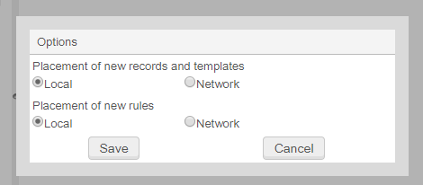

To add rules to convert resource types to Primo supported resource types:

1. Rules > Normalization Rules (DC) > Community > EXL - map dc:type to discovery:resourcetype > View > copy rules into clipboard
2. File > New > Normalization Rules (DC)

Enter name, description, select “Shared” and check “Enabled”

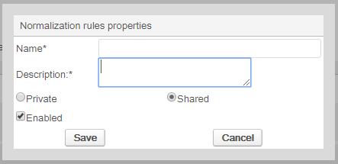

Example rule:

rule "article"

when

"dc"."type" equals "article"

then

set "articles" in "discovery"."resourceType"

end

Alternatively for resource types, you can use a mapping table:

<https://knowledge.exlibrisgroup.com/Primo/Product_Documentation/020Primo_VE/045Loading_Records_from_External_Sources_into_Primo_VE/Using_the_Mapping_Table_to_Map_Resource_Types>

To add rules to create local fields:

Example rule:

rule "move date.created to local field 10"

when

exist "dc"."date.created"

then

move "dc"."date.created" to "discovery"."local10"

end

1. Create local field under Discovery > Manage Local Fields > Add new local field

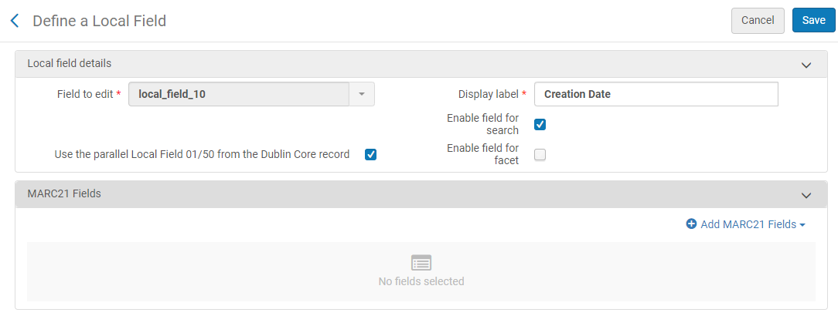

1. Add local field under Discovery > Configure Views > Full Record Services > Details
2. Normalization process tasks – to assign a rule file to a task so task can be added to import profile

<https://knowledge.exlibrisgroup.com/Primo/Product_Documentation/020Primo_VE/045Loading_Records_from_External_Sources_into_Primo_VE/Configuring_Normalization_Rules_for_Primo_VE#Creating_a_Normalization_Rule_Process>

Configuration Menu > Discovery > Loading External Data Sources > Normalization Process Task > Add Process

1. Select “Discovery BIB Records” and “Discovery DC normalization”:

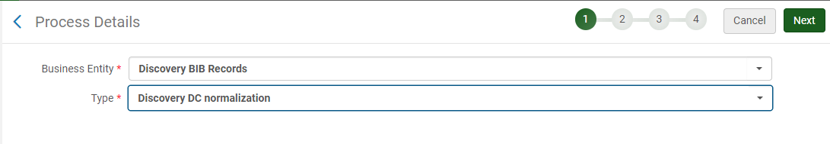

1. Enter name and description:

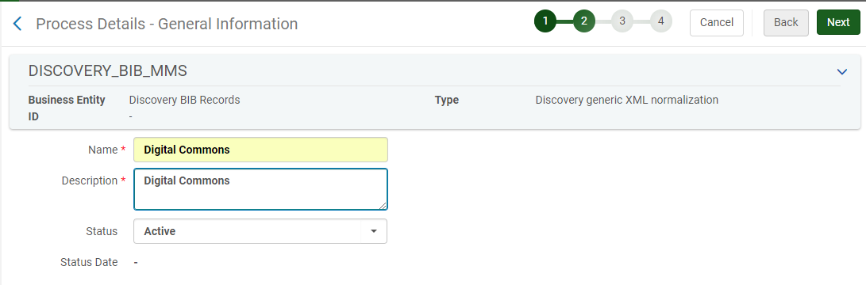

1. Select “Add Tasks”:

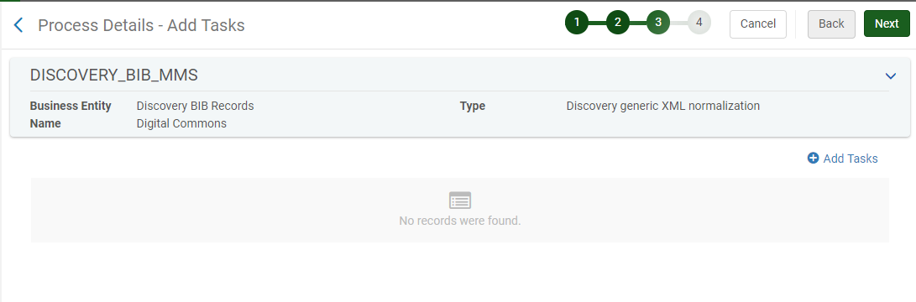

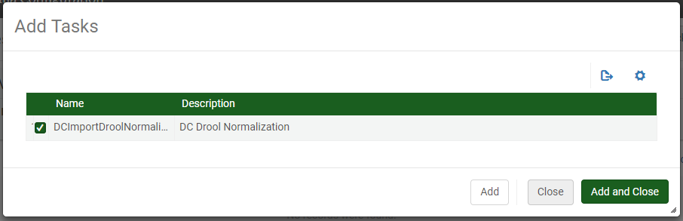

1. Rules created in step 1 will be in dropdown:

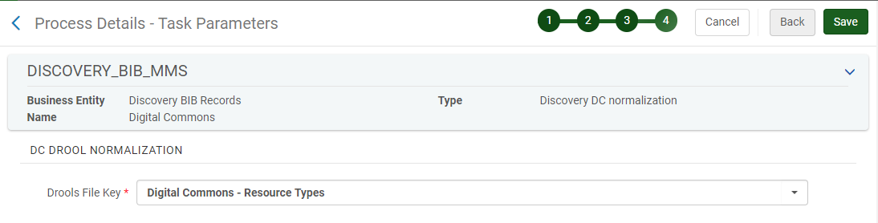

1. Import profile – to configure connection information and select files to load

<https://knowledge.exlibrisgroup.com/Primo/Product_Documentation/020Primo_VE/045Loading_Records_from_External_Sources_into_Primo_VE/Configuring_Import_Profiles_for_Primo_VE>

Configuration Menu > Discovery > Loading External Data Sources > Discovery Import Profiles > Add New Profile

1. Enter values:

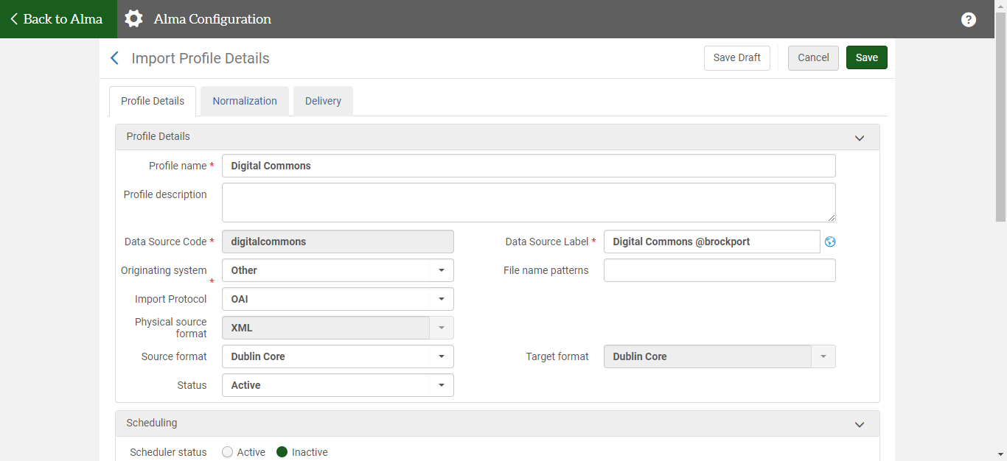

1. Define linking parameter to add the external link to resource:

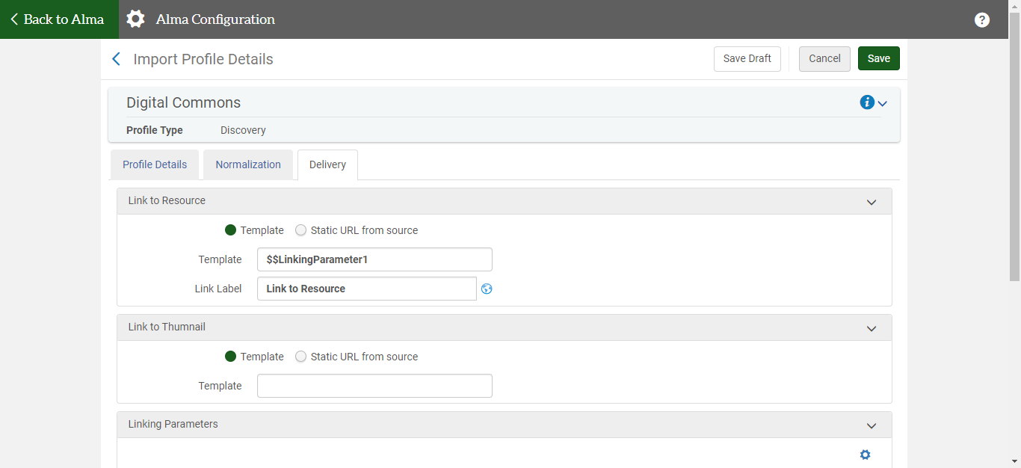

Configure linking parameter:

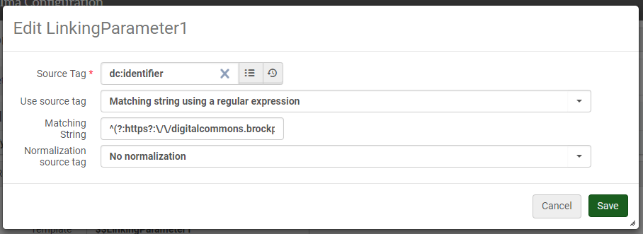

Example: when there are multiple dc:identifier fields and you only want those that have the https://digitalcommons URL

^(?:https?:\/\/digitalcommons.brockport.edu\/cgi\/viewcontent.cgi).\*

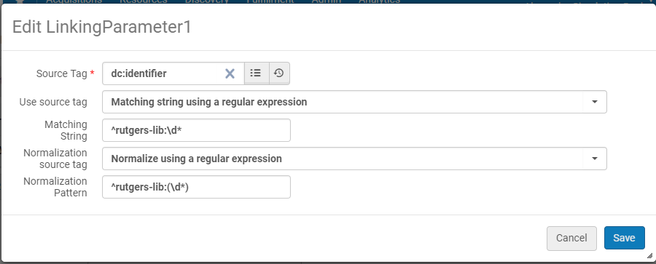

Example: when you need to first match a string and then normalize the string to take the digits only

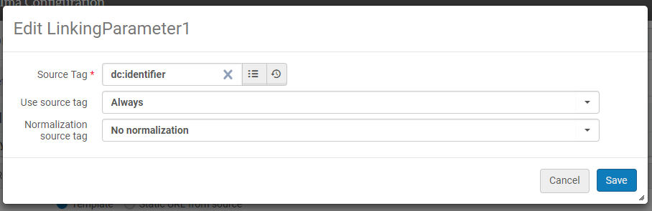

Example: when there is only a single identifier and the full string can be taken

To create test records:

1. Go to an XML record in your repository, ex. <https://digitalcommons.law.buffalo.edu/do/oai/?verb=GetRecord&metadataPrefix=qdc&identifier=oai:digitalcommons.law.buffalo.edu:articles-1008>
2. Copy record into text editor and remove opening/closing OAI-PMH and GetRecord tags. Sample record should have <record> with <header> and <metadata>.

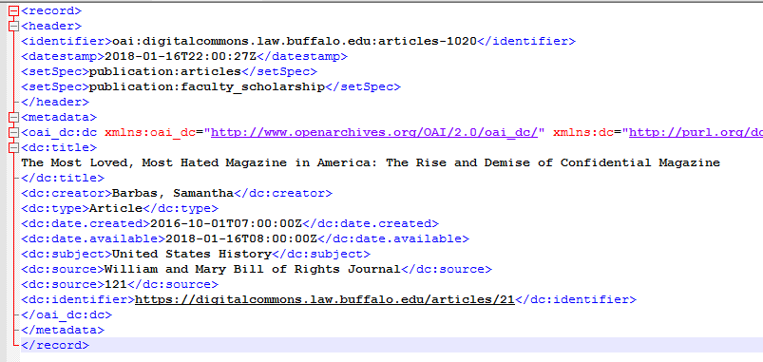

Notes:

1. Records automatically added to My Institution and DiscoveryNetwork search profiles
2. Can also add it as separate search profile:
3. Discovery > Search Profiles > Custom Local Data Scopes (use search index = Available Digital as the condition)
4. Discovery > Search Profiles > Search Profiles
5. Discovery > Configure Views > Search Profile Slots
6. Records are assigned MMS IDs but are not loaded into Alma
7. Supports DC, qualified DC and generic XML
8. For DC, don’t necessarily need normalization rules beyond rules for resource types (or mapping table for resource type)
9. If publishing by sets, be sure to reset harvest start date back to the earliest date stamp
10. If the import completed with errors, try breaking up by sets and republishing
11. If the import completed with errors, double check that normalization rule and task are configured correctly and defined correctly in the import profile