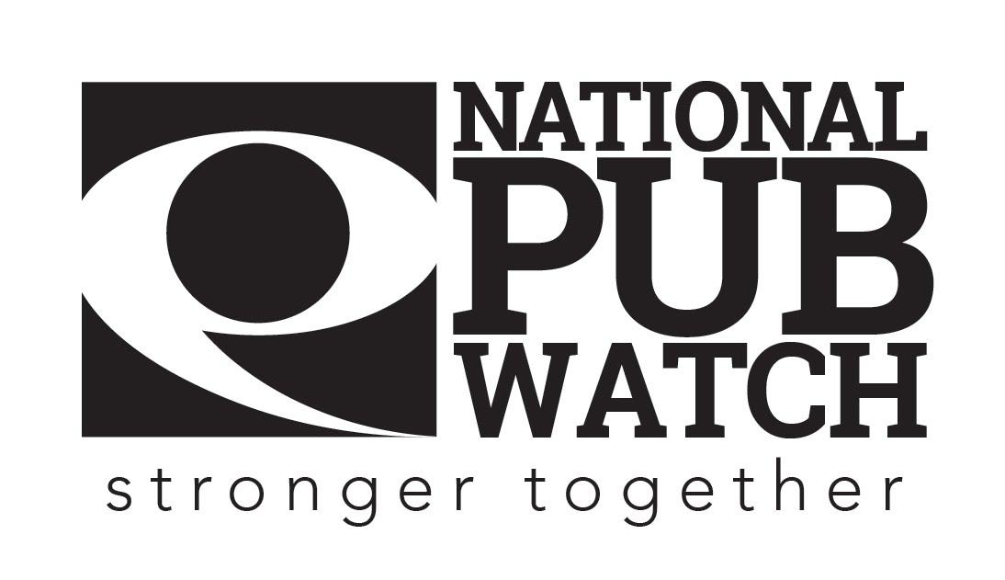

**Promoted Event Risk Assessment Form**

**Date Created:**

**Date of last review: NB Policies should be reviewed annually**

**Expected Standards**

There are 4 licensing objectives of equal importance:

* The prevention of crime and disorder
* Public safety
* The prevention of public nuisance
* The protection of children from harm

**Guidance for Artistes and Promoters**

**(Users should ensure that this guidance sheet is handed or sent to all persons disclosing their personal details)**

The Promotion Event Risk Assessment Form is designed to allow the management of licence premises, promoters of music events, security and the police to work in partnership to identify and minimise any risk of most serious violent crime happening at the proposed event. Should areas of concern be identified the police intention is to work together to identify a Risk Management Plan to enable the event to proceed with minimum risk of most serious violent crime.

The use of this Form is voluntary. However, it is noted that the completion of this Form may be a licence condition on some premises licence, in which case the completion of this Form is mandatory for those premises.

The management of the licence premises or the promoter considers that the proposed event requires a Promotion Event Risk Assessment Form to be completed and it is for this purpose that you and your client’s personal details are required.

The information provided will be cross-referenced with our systems and data sources to assist with the risk assessment.

The information is processed in accordance with our policing purpose as defined by the Code of Practice for the Management of Police Information (MoPI) as follows:

* Protecting life and property;
* Preserving order;
* Preventing the commission of offences;
* Bringing offenders to Justice;
* Any duty or responsibility arising from common or statute law

If you or your client has any concerns or queries regarding the above processing, please contact the [Enter Police Force] Police Service Data Protection Officer (details provided below).

**Data Controller Details: [**enter details of data controller – probably the Chief Constable]

[Address]

**Guidance for Management of licensed premises / event promoter**

When complete please submit via e-mail to [email of local Police licensing officer] to complete an intelligence assessment and copy in the local Police Licensing Unit for their information at least14 days in advance of your event to make sure that there is sufficient time to implement any Risk Management Plan if needed. The area licensing officer will provide you with feedback of your event with no less than 7 days before your event. If you have not received feedback before this time, please contact the licensing team on [Police Licensing Tel no]

**PROMOTION EVENT RISK ASSESSMENT FORM**

The use of this Form is voluntary. However, it is noted that the completion of this Form may be a licence condition on some premises licence. In that case the completion of this Form is mandatory in accordance with the premises operating licence.

|  |  |
| --- | --- |
| **Please complete this section to enable the Licensing Department to monitor the use of this Form.** | |
| **PLEASE NOTE - The use of this Form is not primarily intended for a live music event. If you are using this form for a live music event please give your reasons why in the box.** |  |

**Recommended guidance** to music event organisers, management of licence premises or event promoter on when to complete this form is where you hold an event that is:

* Promoted / advertised to the public at any time before the event, and
* predominantly features DJs or MCs performing to a recorded backing track, and
* runs anytime between the hours of 10pm and 6am, and
* is in a nightclub or a large public house.

The recommended guidance does not restrict the use of the form solely to any specific event. Event managers and promoters may, if they wish, use it for events not strictly covered by the guidance.

***PLEASE COMPLETE ALL SECTIONS.***

|  |  |  |  |
| --- | --- | --- | --- |
| **Name of Premises** |  | | |
| Maximum Capacity of Premises |  | | |
| Full Address |  | | |
| Telephone Number |  | Email Address |  |
| Designated Premises Supervisor |  | | |
| Contact Telephone Numbers |  | |  |

|  |  |  |
| --- | --- | --- |
| **PROMOTER’S DETAILS** | | |
| Promoter’s Full Name  *(include any other names used)* |  | |
| Date of Birth (dd/mm/yyyy) |  | |
| Address |  | |
| Contact Telephone Numbers |  |  |
| Email Address |  | |

|  |  |  |  |
| --- | --- | --- | --- |
| **PROMOTION / EVENT DETAILS** | | | |
| Promotion / Event Name |  | | |
| Event Date (dd/mm/yyyy) |  | | |
| Start Time (HH:mm) |  | Finishing Time (HH:mm) |  |
| Expected numbers attending event? |  | Is this a regular event at this venue? | Yes / No |
| Is the event…? *(Check relevant box)* | Private / Public | Will tickets be sold on the door? | Yes / No |

**Please list below all DJ’s, MC’s, featured Artistes / other promoters performing**

The police need the minimum of name and date of birth to cross-reference with their systems and data sources. An address is needed for confirmation of identifying the individual. It is recommended that the data submitted on the form are verified by the person submitting this form.

|  |  |  |  |  |
| --- | --- | --- | --- | --- |
| Real Name | | Role and other name used *(i.e. stage name)* | Date of Birth  *(dd/mm/yyyy)* | Address |
|  |  | |  |  |
|  |  | |  |  |
|  |  | |  |  |
|  |  | |  |  |
|  |  | |  |  |
|  |  | |  |  |
|  |  | |  |  |
|  |  | |  |  |

|  |  |  |  |
| --- | --- | --- | --- |
| **SECURITY FOR THE EVENT** | | | |
| Please provide the name of the security company to be used | |  | |
| Contact Name at Security Company to be used | |  | |
| Registration No. |  | Email |  |
| Contact Nos. of Security Company |  | | Mobile: |

|  |  |  |
| --- | --- | --- |
| **SECURITY DETAIL AND DEPLOYMENT** | | |
| Number of door supervisors |  |  |
| Please outline below how you propose to deploy your security staff and what equipment will be available to facilitate searching on entry | | |
|  | | |
| Total Security Staff |  | |
| Performer / Artiste Security  *(Show company name & contact numbers)* |  | |

|  |
| --- |
| Do you have other knowledge that would need special considerations to be made to limit crime and disorder? If so, please give details below. |
|  |

When complete please e-mail this whole document **at least 14 days in advance** to: [email of local Police licensing officer]

**Please sign this document to acknowledge that you have understood the Promoted Event Risk Assessment and what you are required to do.**

Date: …………………………………………………………………

Trainer’s Name: ……………………………………………... Trainer’s Signature: …………………………………….

Trainee’s Name: …………………………………………….. Trainee’s Signature: ……………………………………