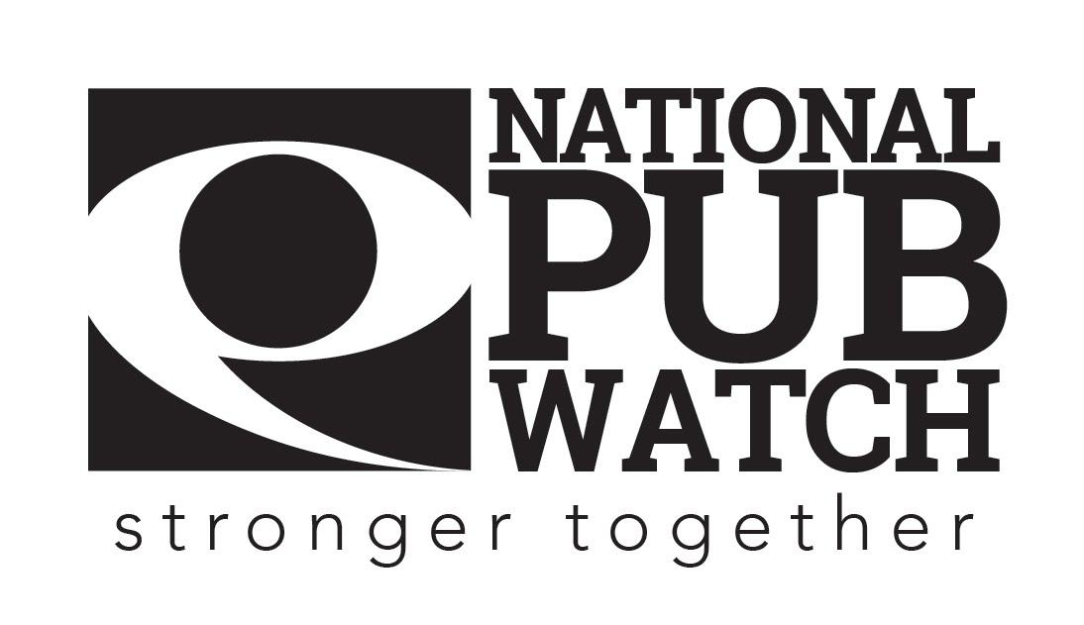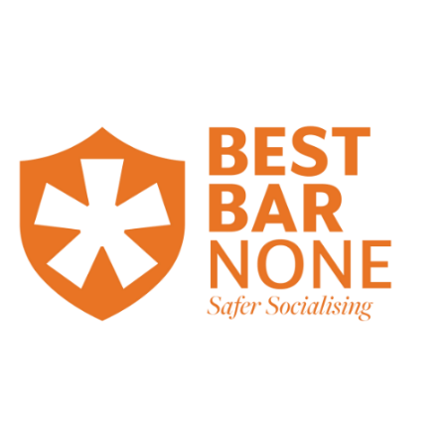

**Safeguarding and Vulnerable Persons Policy**

**Date Created:**

**Date of last review: NB Policies should be reviewed annually.**

**Expected Standards**

There are 4 licensing objectives of equal importance:

* The prevention of crime and disorder
* Public safety
* The prevention of public nuisance
* The protection of children from harm

Safeguarding sits under the protection of children from harm section and the public safety sections, and we have a legal obligation to protect children and vulnerable adults from harm. Safeguarding is a term we use to describe how we protect adults and children from abuse or neglect and is an important shared priority of businesses, local authorities, and the police.

As a business, we want to ensure all of our customers can enjoy our facilities free from harm, and we are committed to protecting the most vulnerable in society by ensuring that if we are worried about someone's safety our staff are equipped to deal with it.

**What to look out for?**

Alcohol can often make people more vulnerable particularly those who might be at risk from child sexual exploitation, domestic abuse, or people taking advantage of a physical or mental disability.

These people may be at risk of abuse or neglect due to the actions (or lack of action) of another person. In these cases, licensed businesses must work together to identify people at risk and put steps in place to help prevent abuse or neglect.

**Abuse and neglect take many forms: These are the recognised forms of adult and child abuse**

* **Physical Abuse:** Non-accidental harm to the body. It can range from physical injuries such as hitting, pushing, wounding etc. to things such as misuse of medication, inappropriate use of restraint and dehydration/malnourishment.
* **Domestic Violence:** Physical, sexual, psychological or financial violence that takes place within an intimate or family-type relationship and forms a pattern of cohesive and controlling behaviour’.
* **Sexual Abuse:** Includes sexual assault or sexual acts which have not been consented to. Also, encompasses rape and non-contact abuse such as sexual harassment or pornography.
* **Child Sexual Exploitation:** This could be a combination of a number of categories of abuse. It can take place anywhere, but often Licensed Premises may be used as a lure for vulnerable children. They may be plied with alcohol and other intoxicants then groomed for the sexual gratification of a number of adults. Things to look out for are the same adult coming to the bar with different children, or the same child coming to the bar with different adults. Inappropriate touching or language, the child looking uncomfortable or nervous in the presence of the adult.
* **Psychological/Emotional Abuse:** Mental abuse such as threats, abandonment, intimidation, humiliation, deprivation of physical or emotional contact and cultural needs. Can also include verbal abuse. Psychological abuse can be harder to spot as it is often done in private and has no physical signs.
* **Financial or Material Abuse:** Can encompass internet scams, fraud or theft of property but also alludes to control over financial ownership such as wills, inheritance or property.
* **Discriminatory Abuse:** Unequal treatment of a person due to their race, gender, age, disability, sexual orientation or religion.
* **Organizational Abuse:** The mistreatment, abuse or neglect of a person in a setting where the person lives or a service that they use.
* **Modern Slavery:** Modern slavery is a hidden crime and targets people living in poverty or with a lack of education or unstable social conditions. Modern Slavery encompasses slavery, domestic servitude, human trafficking and forced labour. It is an international crime and can include victims that have been brought over from overseas and vulnerable people within the UK who are forced to work illegally against their will, often in illegal establishments.
* **Neglect and Acts of Omission:** Includes all aspects of neglect such as deprivation of food, shelter, clothing or heating. Abusers can also harm victims by ignoring their medical or physical needs, which is mostly applicable in a care situation where abuse can occur through failing to provide medication to a person, banning visitors or ignoring/isolating the person.
* **Self-Neglect:** Self-Neglect is a little different to the other types of abuse as this is inflicted from an individual to themselves and focuses on a lack of self-care so much that it affects personal health and safety. Self-Neglect also encompasses self-harm, failing to care for one’s personal hygiene, surroundings, or health.

**When to step in and what to do**

All staff performing a public facing service should receive appropriate basic training to understand vulnerability and how to support vulnerable customers.

**Ask for Angela**

Consider using the “Ask for Angela” ([http://www.askforangela.co.uk/](http://www.askforangela.co.uk/)%20)) campaign (or similar). Posters can be placed in strategic locations encouraging vulnerable people to “Ask for Angela” to ask for help from the venue staff to extricate them from a situation. If you do use this campaign, please ensure that **ALL** members of staff who are likely to interact with customers in any way, are fully conversant with the campaign and what to do if someone “Asks for Angela”

**Have a means of contacting the members of any scheme such as the Street Pastors which deal with vulnerable people**

Door staff and management will maintain the existing dialogue with the [name of city/town] Street Pastors (or any organisation performing a similar function in the nighttime economy). The Street Pastors can be contacted via [e.g. the CCTV control Room via the Pub link radio system, telephone number]

**Have a direct line of communicating with the local authority CCTV operators i.e. the pub link radio**

If you are a member of the local Pub link radio system. The radio will normally be carried by the management or head door supervisor.

**Identification of a “Safe Area” inside the venue where vulnerable people can remain and be cared for until their safety has been ensured.**

The [enter location] has been identified as a safe area, however [enter location] area may also be used if the situation is not too serious.

**Have a nominated member of staff who will be responsible for dealing with any vulnerable people associated with the venue.**

The [general manager and DPS] will be the responsible person for ensuring the continued welfare of vulnerable people, he/she may delegate such responsibility as appropriate to other duty managers working at the premises.

**Have a register documenting the incidents where vulnerable people have been identified and the actions taken by the venue to ensure their safety.**

Any incidents where vulnerable people have been identified will be fully reported in the [incident/ vulnerable person] reporting register. This will include the issues that caused the vulnerability in the first place, staff members involved in the care of the vulnerable person, the final result/disposal. Any such reports must be signed off by the DPS

**Have a list of local taxi company details to be provided to customers upon request and when required arrange a taxi on behalf of a customer.**

[Local Taxi firm numbers will be displayed in the foyer of the premises. Staff members will always call (free of charge) a taxi for any vulnerable person upon request.]

**(Optional)**

**A nominated manager to be present and to remain in the main customer entry area no later than 30 minutes prior to closing time to ensure the safe and quiet exit from the premises by all customers.**

The [general manager/ DPS/door staff] will be the responsible person for ensuring the safe and quiet egress of customers from the premises. Ordinarily he/she will be positioned within the foyer of the premises [at least 15/20/30 minutes prior] to the terminal hour.

**Reporting vulnerable adults**

* Assess the situation i.e. are the emergency services required? If the person is in immediate danger, or fear for their safety, wellbeing or life then yes call the emergency services either on 999 or the Police on 101, dependent upon the circumstances.
* Ensure the safety and wellbeing of the individual this may mean separating them from their abuser or taking them to the “Safe Area” (see above).
* Establish what the individual’s views and wishes are about the safeguarding issue and procedure – remember any investigations will always be ‘victim led’ so they cannot be forced into a certain course of action, but should be encouraged to report it to either the Police or other support groups to assist them in breaking the cycle of abuse.
* Maintain any evidence [for example CCTV, if they consent record on your phone what they say]
* Follow local procedures for reporting incidents/risks [ask your local licensing or safeguarding team]
* Remain calm and try not to show any shock or disbelief
* Remember do not ask leading questions stick to :

1. What happened?
2. When did it happen?
3. Where did it happen?

* Listen carefully and demonstrate understanding by acknowledging regret and concern that this has happened, repeating what has been told to you serves two purposes, it demonstrates to the victim that you are listening and also ensures that accuracy is maintained.
* Inform the person that you are required to share the information, explaining what information will be shared and why
* The information you need to collect is
  + Name
  + Date of Birth
  + Address
  + Contact details
* Make a written record of what the person has told you, using their words, what you have seen and your actions.

**Reporting vulnerable children**

Take the steps as detailed above however some further steps can be taken:

* **If the child is not in immediate danger**
  + Work with the child to establish if a responsible adult can come and pick them up
  + Report it to your local authority's children's social care [find your local authority contact information on [www.Directgov.co.uk](http://www.directgov.co.uk) ]
* **In the child is in immediate danger**
  + Report it to your local police.
  + If you aren’t sure, contact the NSPCC's helpline, which you can reach at 0808 800 5000 or via their website

**REMEMBER** – Doing nothing is not an option. You wouldn’t want any of the above forms of abuse to happen to a member of your family. You could be the person that helps the victim break the cycle of abuse that they may have been subject to for months or even years.

I understand that it is my responsibility to report any abuse or neglect I witness to my line manager immediately, discreetly, and away from other customers.

**Please sign this document to acknowledge that you have understood your responsibilities in regard to safeguarding.**

Date: …………………………………………………………………

Trainer’s Name: ……………………………………………... Trainer’s Signature: …………………………………….

Trainee’s Name: …………………………………………….. Trainee’s Signature: ……………………………………