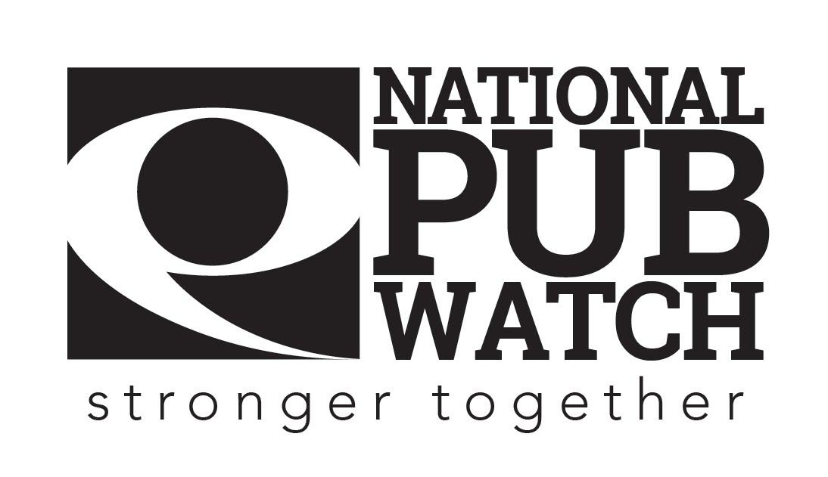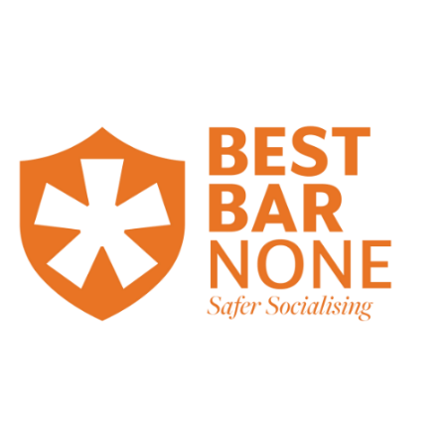

**Challenge 25 policy**

**Date Created:**

**Date of last review: NB Policies should be reviewed annually.**

**Expected Standards**

There are 4 licensing objectives of equal importance:

* The prevention of crime and disorder
* Public safety
* The prevention of public nuisance
* The protection of children from harm

](https://beerandpub.com/challenge-21-25/)Our ***Challenge 25*** policy applies to all age-related sales that occur on our premises. You are obliged to apply our ***Challenge 25*** policy when any customer who looks to be under the age of 25 attempts to purchase alcohol, either for themselves or for somebody else.

If you sell alcohol to anyone under 18, youare breaking the law. The consequences are very serious; you could receive a £90 Fixed Penalty Notice or if prosecuted be fined up to £5000, which may result in a conviction being recorded against your name. If you are a Personal Licence Holder, your Personal Licence is also at risk of forfeiture.

Additionally, both the pub and the Designated Premises Supervisor (DPS) or Owner could face prosecution as a result of your actions, as well as having its licence suspended or revoked.

Our ***Challenge 25*** policy requires you to use a 4-step approach every time you see someone who appears to be under the age of 25:

1. Assess the age of every customer.
2. If you think the customer *looks* under 25, ask for ID.

[Only the following documents are acceptable for proof of age purposes]:

* **A valid Passport**
* **A valid photo drivers’ licence**
* **A “Pass” approved card from the national Proof of Age Standards Scheme**
* **A British Military ID Card**
* **A National Identity Card**

Only **Original Documents can be accepted -** photocopies, photographs or **Phone Apps** and out of date passports are **not acceptable**

1. If the customer cannot produce acceptable ID, refuse the sale of alcohol
2. When you refuse the sale you must record this in the refusals log book/EPOS system on the till

There are fake proof of age cards, so if you are unhappy with the ID for any reason or it looks fake or tampered with, or you think it belongs to someone else (eg a brother or sister), refuse the sale and bring the matter to the attention of your Duty Manager or Supervisor.

***Challenge 25*** applies at all times, even when:

* You think door staff has previously checked a customer’s ID.
* You are busy.
* You believe you have seen acceptable ID from the customer on a previous occasion.

Remember, if you ask for ID from everyone you think looks under 25, then you will protect yourself from breaking the law. Practice ***Challenge 25*** and do not get caught out.

**Please sign this document to acknowledge that you have understood your training and responsibilities and agree to always ask for ID from customers who appear to be under the age of 25.**

Date: …………………………………………………………………

Trainer’s Name: ……………………………………………... Trainer’s Signature: …………………………………….

Trainee’s Name: …………………………………………….. Trainee’s Signature: ……………………………………