**Progressive Muscle Relaxation**

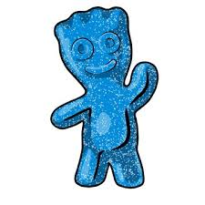**Pretend you just ate a really sour candy. Scrunch your face up as much as you can. Now relax and let your jaw hang open.**

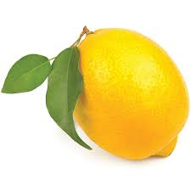

**Now pretend you are squeezing juice out of a lemon and squeeze your hands as tight as you can. Now let go and notice the difference.**

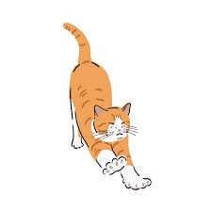

**Next pretend you are a cat and stretch your arms and legs out as far as you can. Now drop your arms and legs and let them totally relax.**

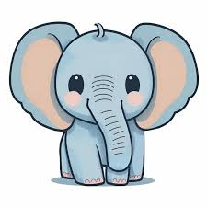**Now pretend an elephant sat on your stomach. Make your stomach tight like a board to hold him. Now relax and take a deep breath.**