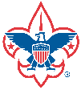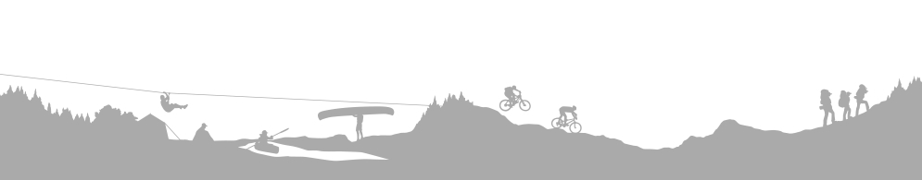

***Scout Shop Holiday Giving Tree Begins November 12***

*Your Help Is Requested*

October 26, 2021

The Cleveland Scout Shop is providing an opportunity for the Scouting community to help local Scout members who may need uniforms and uniform items.

This help will be done through **The Holiday Giving Tree** program starting **November 12 through December 17**, 2021. **The Holiday Giving Tree** program works on a donation basis. A Holiday Giving tree (similar to an Angel tree) will be set up at the Scout Shop with Holiday Giving cards on it. Each card will have the first name of the Scout along with the uniform items that they need. There will also be a space for other items they may want such as books, crafts, camping items, etc. Customers and Scout supporters can purchase the item(s) in their local Scout Shop and give them to the store staff to collect for each child.

We will keep the name of the individual(s) **confidential**. Only the store staff will have access to the Scout’s name and your contact information. A code will be issued that will match a card in the safe that will have your contact information, so as the donations are collected store staff will contact you so arrangements for pickup can be made.

We need your assistance to make this project a success. Please fill out the information below and return to the store by **November 11**, 2021, for every Scout who would benefit from donations.

If you have any concerns or questions, please contact the store staff by email: [paula.puchajda@scouting.org](mailto:paula.puchajda@scouting.org). Thank you in advance for your assistance. With leaders like you, this program will greatly benefit our Scouting community.

**Scout Information:**

Youth’s Name ___________________________________ Code/Number: _________________ (For Scout Shop Only)

Leaders Name ___________________________________ Phone # ______________________

Troop or Pack # __________________________________ Rank _________________________

**Items that would benefit the Scout:**

Shirt: Size ____________ Neckerchief __________ Pant: Size ____________

Slide ________________ Cap: Size: ____________ Socks: Size ____________

Belt: Size _____________ Insignia ______________ Belt Buckle ___________

Other Items _____________________________________ Book ________________

Thank you, Cleveland Scout Shop Staff!