Receiving Continuous Orders Print Subscriptions (Serials Check-In)

You must be signed into a location that allows for Acquisitions.
Under the “Acquisitions” menu, go to “Receiving and Invoicing => and click on Receive.” The brings you to a new screen that reads Receive New Material. Select the tab which reads “Continuous” to see a list of subscription titles with issues to be received.
Just above the Continuous tab there is a Keep in Department checkbox.
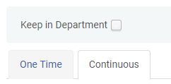
Leave “Keep in Department” unchecked if you are receiving an issue that does not need physical processing.
Check “Keep in Department” if you are receiving an issue that needs physical processing (i.e. printed label, property stamp, tattle tape). Choose Physical Processing from the drop down list that appears next to the checkbox.
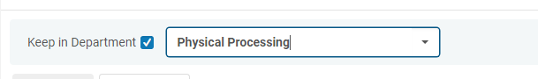

You can find the item you want to receive by filtering by vendor and/or searching by PO-Line number, title, ISSN, or other criteria.
Choose your title by hovering over its line then click on the ellipse (three dots) that appears to the left on that line. If a publishing pattern has not already been established, it will give you two choices: Manage Items or Receive.
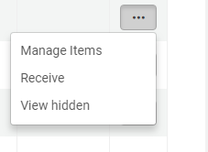
Select Manage Items to see a list of previously received issues. Note that If you choose Receive on the dropdown list instead of Manage Items this doesn’t allow you to view previous issues first.

After clicking on Manage Items you will be on a new page with a tab called PO line items and another tab Bibliographic Information will be next to it. Under the PO line items tab click Receive New Items (above barcode and description columns) to go into the next screen. Note the status of Keep in Department and check or leave unchecked as per instructions above.

You are now on the Receive New Items page that gives you item level details. You must enter new item information in Enumeration A and Chronology I (you can click duplicate the last item details and update the info.) Add information to the Description field to match enumeration and chronology of the new issue, i.e special issue. Press the Generate button to the right of the Description field to update that field. Then click Receive and Set Barcodes. This gives you a Set barcodes dialog box with a barcode field where you can accept a system generated barcode or enter your own. Click Submit. Click Save.

The Description field is what Primo and Alma use to identify the context of a request when it is placed. Requests from or for Patrons via Primo or Alma will be selected from item level descriptions therefore if a value is entered in the Description field the item is treated as a serial and will be displayed as such in the Get It tab (readily identifiable as a serial on the patron side display).

If no value is recorded (left blank) for the Description field under New item details the item is then treated as a monograph, however, either the Enumeration A or Chronology I field must have a value. You would click Receive and Set barcodes at the top of the page. It will give you a message “The description may need to be updated as well (using the generate button)” you will hit Confirm to continue and you will then be given the dialog box to add the barcode and then hit Submit. The Description field, however, is not a general notes field and does conform to a pattern.

Receiving a serial with no items listed (creating the first item):
If no item already exists no item lines will appear under the publication name. Click on Receive New items. You will now be on the Receive New Items page. Add appropriate information in Enumeration A and Chronology I fields. You can also add to the description field. You can now click on Create and Receive. If no information has been added to the description field you will get the dialog box asking you to Cancel or Confirm. After you choose Confirm this will take back to the Received Items List page of your publication and it will now have an item line. A date will appear in the Date Received column and a system generated barcode will appear in the Barcode column. In order to change the barcode you will have to go back to the Physical Item Editor page by clicking on the Edit Inventory Item choice in the ellipse drop down to correct barcode. Click on Save after barcode has been updated.

Receiving Serials with Prediction Patterns Already Established
Select “Receive” from the ellipse list. A date will appear in the “Date Received” column, and a note will be added in the “Current Step” column for Physical Processing.
Click on the same ellipse again and this will now give you a drop down with eight choices. Select “Edit Inventory.”
This brings you the Physical Item Editor. Stay on the “General” tab and add in the barcode. (If you are using system generated barcode, hit “Generate.”
After you have added the barcode, to the top right of the page and select “Save” from the menu.
If you see the following dialogue box:
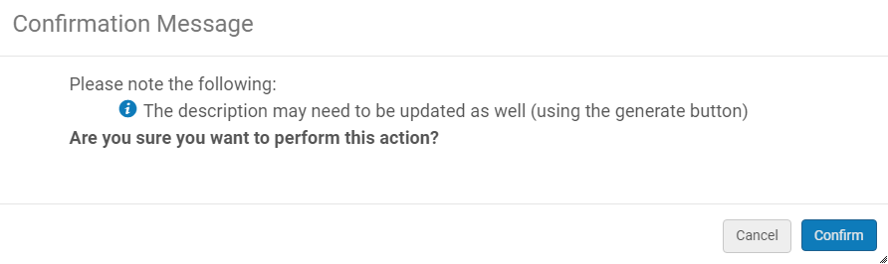
Select “Confirm” if no changes are needed.
Select “Cancel” to edit the “Description” in the “General” tab and then proceed with the above directions.
By hitting “Confirm,” you will be sent back to the “Received Items” page.
The barcode will now be populated. Select the ellipse to the far left and choose “Done.”
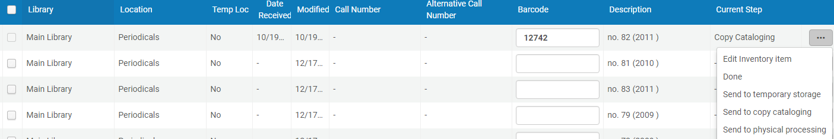

It will then move the item to “Processing.” Alternatively, you can select a different Processing status as needed.
Click Save on top of the Received Items List tab and it will return you to the Receive New Material page.

Additional links for helpful information:
- Print Serials (ELKC) - https://knowledge.exlibrisgroup.com/Alma/Product_Materials/050Alma_FAQs/Print_Resource_Management/Print_Serials
- Managing Physical Items (ELKC) – includes information on predictive patterns
https://knowledge.exlibrisgroup.com/Alma/Product_Documentation/010Alma_Online_Help_(English)/040Resource_Management/050Inventory/040Managing_Physical_Resources#Creating_a_Holdings_Record_with_Predictive_Pattern_Content

- Configuring Description Templates (ELKC) - allows for easier work with Enumeration and Chronology https://knowledge.exlibrisgroup.com/Alma/Product_Documentation/010Alma_Online_Help_(English)/040Resource_Management/080Configuring_Resource_Management/150Configuring_Description_Templates
- Alma Training-Acquisitions Workflows-Receiving Continuous Print Items
https://knowledge.exlibrisgroup.com/Alma/Training/Alma_Workflows/Acquisitions_Workflows/3_Receiving_Workflows/2_Receiving_Continuous_Print_Items
- Serials Check-in Workflow (URi)
https://sites.google.com/a/uri.edu/librarytechserv/home/serials_acq/serials_checkin

- Indicating Enumeration and Chronology in Alma (URI)
https://sites.google.com/a/uri.edu/librarytechserv/home/serials_acq/enum_chron

