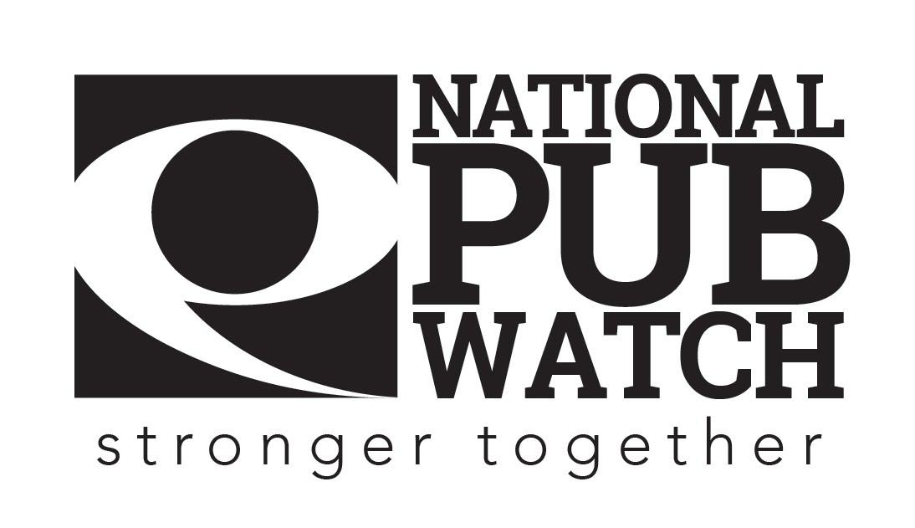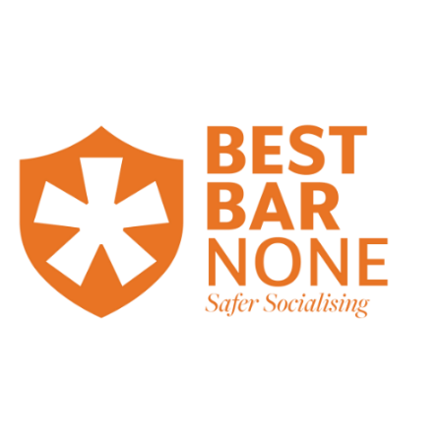

**Gambling and Protecting the Vulnerable Policy**

**Date Created:**

**Date of last review: NB Policies should be reviewed annually.**

**Expected Standards**

There **are 3 objectives of the Gambling Act 2005** and therefore we have set out below the policies and procedures **[enter name of venue]** undertakes in its premises to promote these objectives.

In addition, the **Gambling Commission's "Gaming Machine Permits Code of Practice”** is complied with. https://www.gamblingcommission.gov.uk/authorities/guide/page/section-c-gaming-machines-in-clubs-and-premises-with-an-alcohol-licence

**Objective 1. Protecting children and other vulnerable people from being harmed or exploited by gambling;**

To ensure that no persons under the age of 18 are permitted to play on our gaming machines, we abide by a **[enter age verification policy Challenge 21/25]** in our premises.

Under this policy, all of our employees are trained to ask any customer playing a gaming machine, who appears to be under the age of **[21/25 years]** to provide valid proof of age that they are over the age of 18.

**[Enter name of venue]** recognises only the following forms of identification as valid forms of proof of age: **[edit]**

* National passport
* Photographic Drivers' Licence
* United Kingdom 'PASS' accredited age identification card with photograph.

In certain circumstances, other forms of ID are accepted at the discretion of the manager on duty such as international ID cards or military ID cards.

* All staff are aware of their responsibility for preventing underage gambling.
* All machines are situated in a place where their use can be supervised.
* All staff have been provided with safeguarding training and know how to report or raise a safeguarding concern.

**Objective 2. Preventing gambling from being a source of crime or disorder, being associated with crime or disorder, or being used to support crime;**

**[Edit and add as relevant to your premises]**

* The power to all gaming machines is turned off after the pub has closed to ensure potential thieves are not attracted by the lights in the pub.
* We ensure all of our gaming machines are placed in sight of appropriate CCTV coverage.

**Objective 3. Ensuring that gambling is conducted in a fair and open way**.

* All of our AWP machines are located in well supervised areas fully open to the public at large and are provided by reputable companies.

**Please sign this document to acknowledge that you have understood your responsibilities in regard to gambling and protecting vulnerable people.**

Date: …………………………………………………………………

Trainer’s Name: ……………………………………………... Trainer’s Signature: …………………………………….

Trainee’s Name: …………………………………………….. Trainee’s Signature: ……………………………………