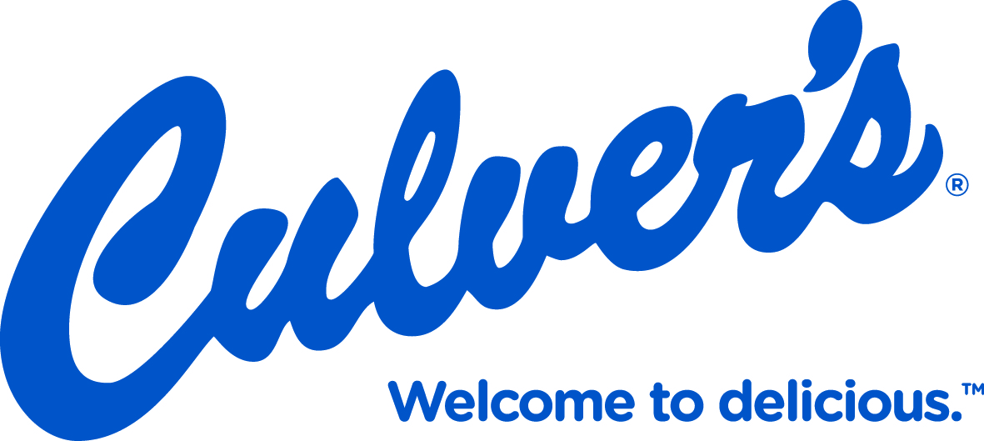

10% of the sales from this slip will go to the:
Red Raider Robotics

Amount: $___________________
Locations:
Culver’s of Sheboygan:
2510 Washington Avenue
641 South Taylor Drive
4225 HWY 42
February 12, 2020
ALL DAY EVENT
Feel free to make extra copies and hand them out to your students, family and friends!

